Table of Contents

1. MySQL Backup and Restore 2

1.1. mysqldump 2

1.1.1. Backup mysql database: 2

1.1.2. Restore mysql database: 6

1.1.3. Backup multiple database: 11

1.1.4. Restore multiple database 13

1.2. Percona Full/Incremental Hot Backup/Restore 17

1.2.1. Percona Full Hot Backup 17

1.2.2. Performing Backup Restoration 27

1.2.3. Performing Percona Incremental Backup 30

1.2.4. Preparing Restoration of Percona Incremental Backup 32

1.3. MySQL Enterprise Backup/Restore 36

1.3.1. MySQL Enterprise Backup 36

1.3.2. MySQL Enterprise Restoration 42

1.3.3. MySQL Enterprise Incremental Backup/Restoration 45

2. MSSQL Backup and Restore 48

2.1. MSSQL Backup 48

2.2. MSSQL Restore 51

REFERENCES 53

# MySQL Backup and Restore

## mysqldump

By executing the below mentioned command, all databases structure and data will be exported to a single [dump_file.sql] dump file.

SYNTAX: mysqldump -u [username] -p[password] [database_name] > [dump_file.sql]

Where:

* [username]: valid MySQL username
* [password]: valid password for the user. Note that there is no space between -p and the password
* [database_name]: database name you want to backup
* [dump_file.sql]: dump file you want to generate

### Backup mysql database:

STEPS:

1. Let us know, the status of the server using: **service mysqld status**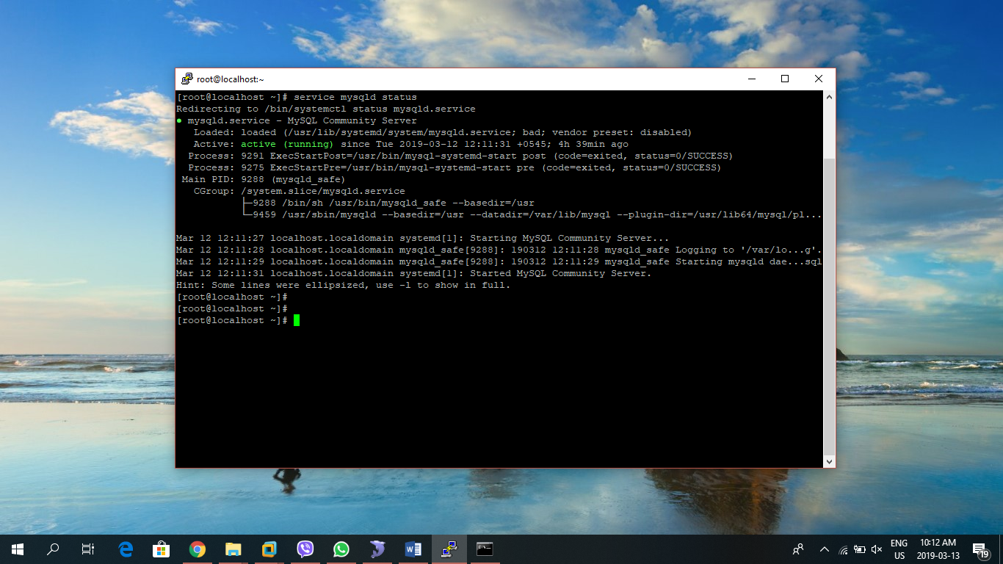
2. Login to the mysql service using root: **mysql -uroot -p**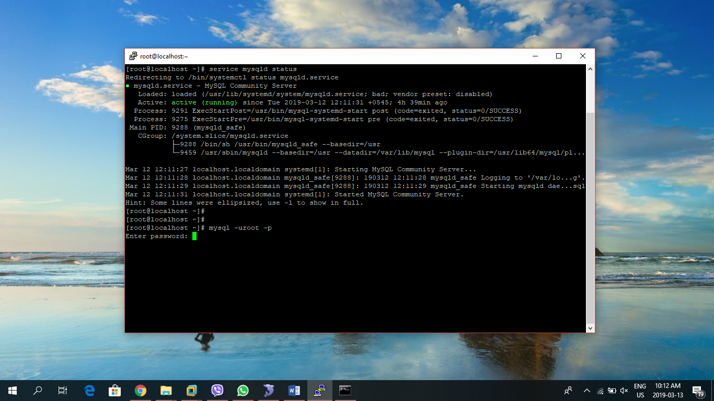
3. Use **show databases** to see the list of databases on that server: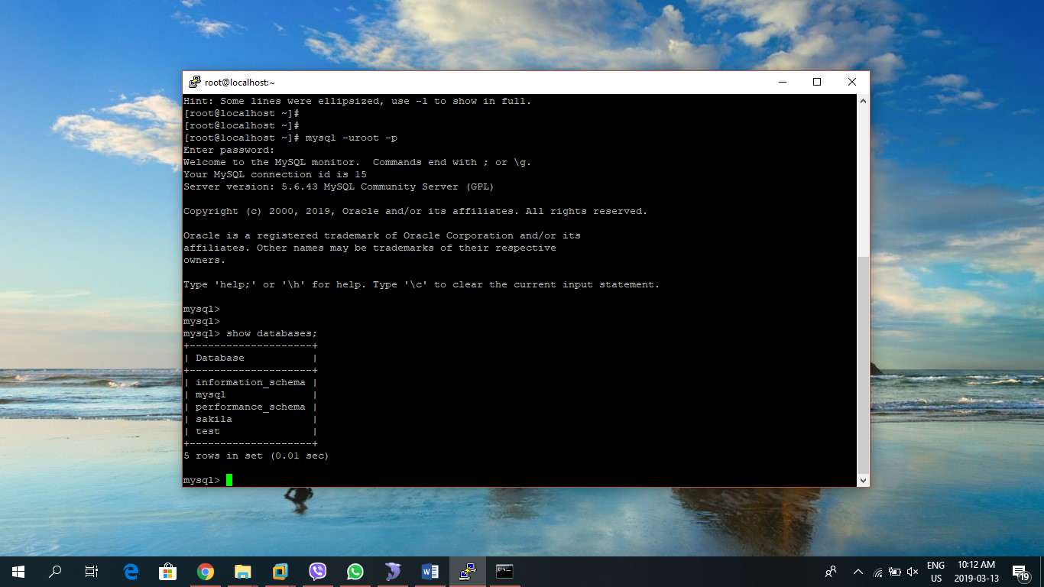
4. Here, we will backup the **sakila** database using **mysqldump**
5. Let us first make a directory **backup** where our backup sql file we be created. Use the following command to create new directory named backup: **mkdir backup**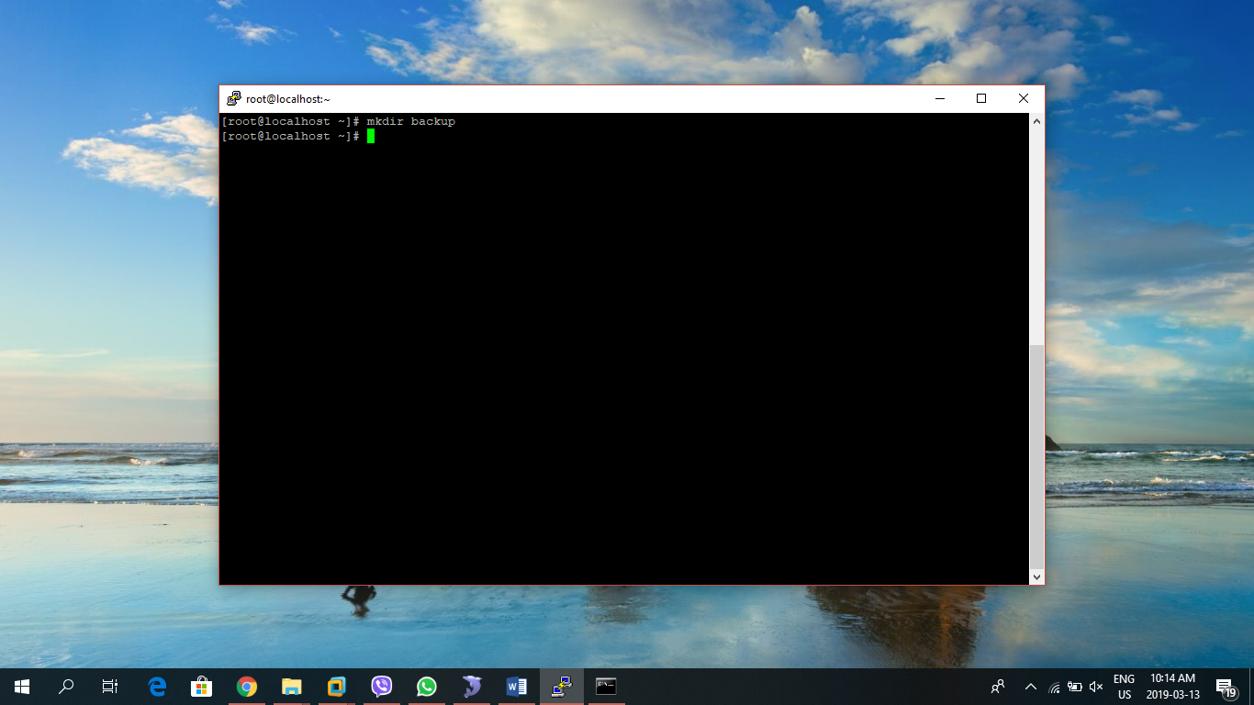
6. Now, change the directory to backup using: **cd backup/**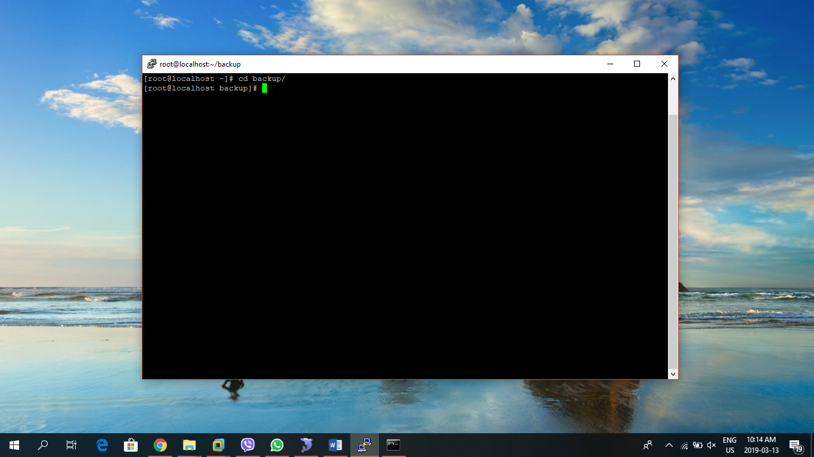
7. This is where the backup file will be created. Use the following command to create a backup named sakila_bckup.sql: **msqldump -uroot -p sakila > sakila_bckup.sql**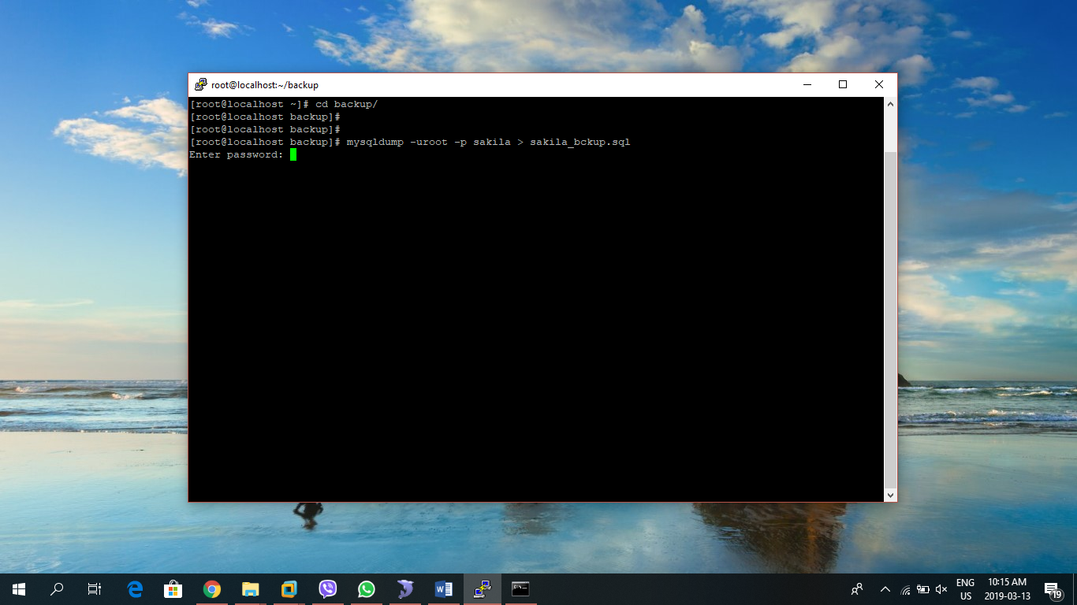
8. We can view the created file using **ls** command: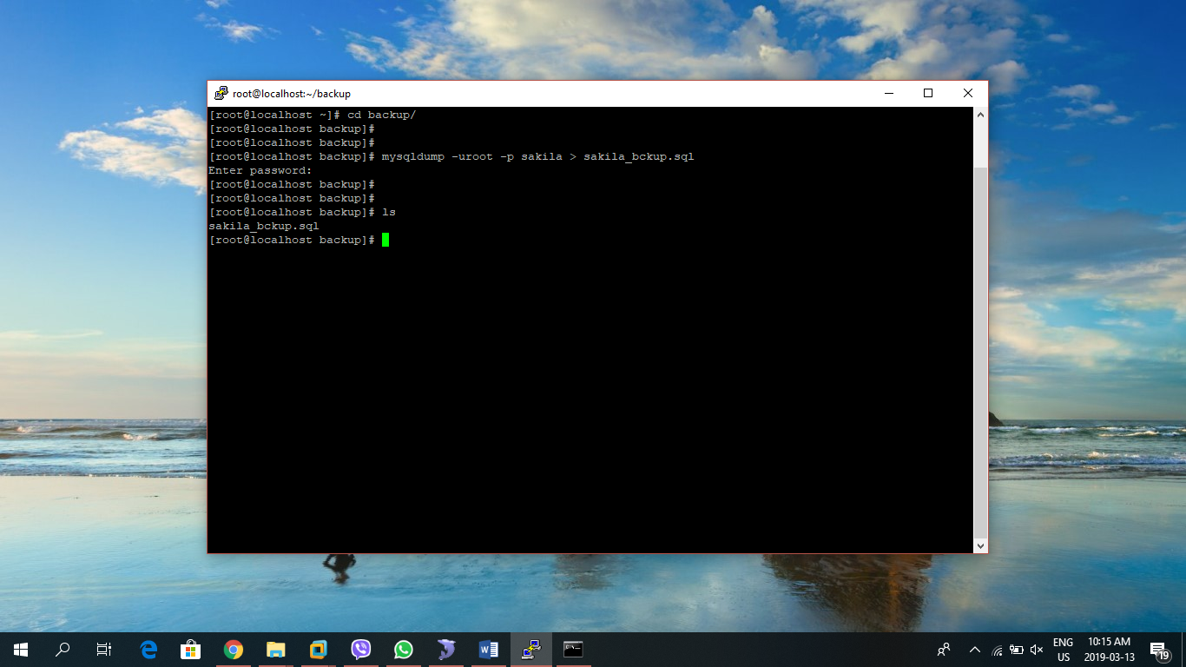

### Restore mysql database:

STEPS:

1. Let us verify there is no database named sakila in the server: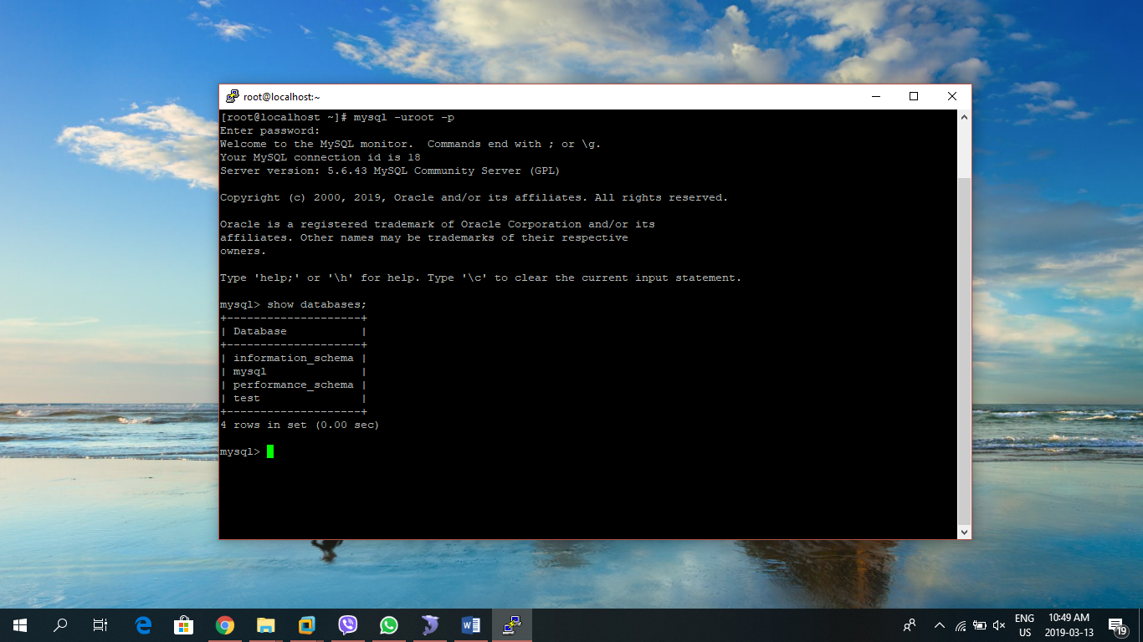
2. Move to the directory backup where our backup file is present using: **cd backup/**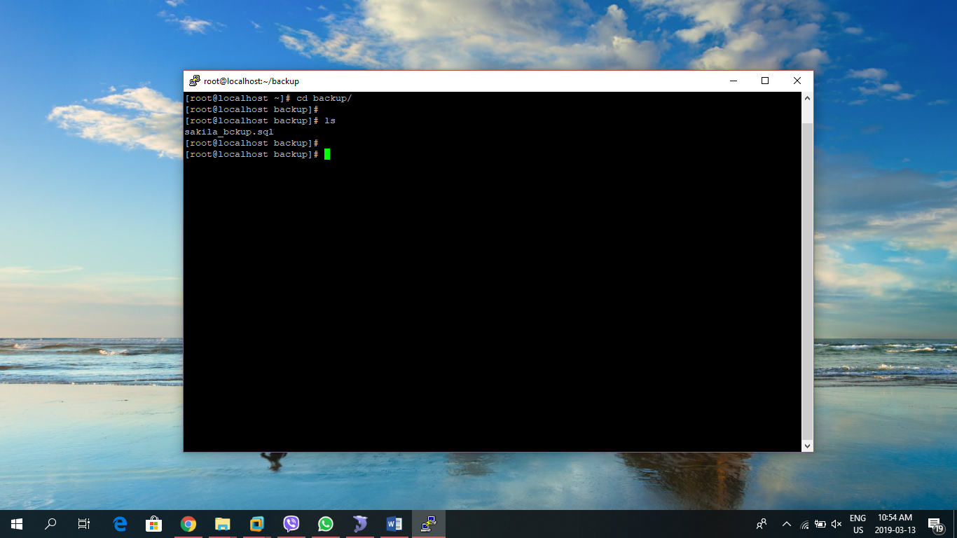
3. Now, to restore the sakila database we use the following command: **mysql -uroot -p sakila < sakila_bckup.sql**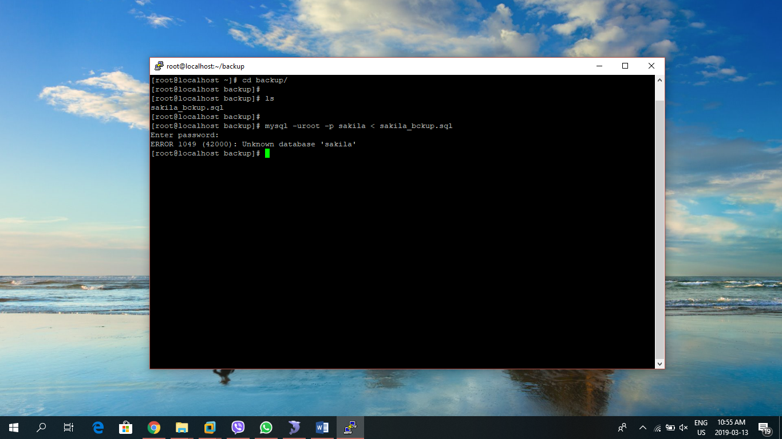

NOTE: First of all, we should create a dummy database named sakila before restoring the database. This ERROR occurred because there is no database sakile where the backup sql can be executed.

1. Now to create the database,first login to mysql using root: **mysql -uroot -p**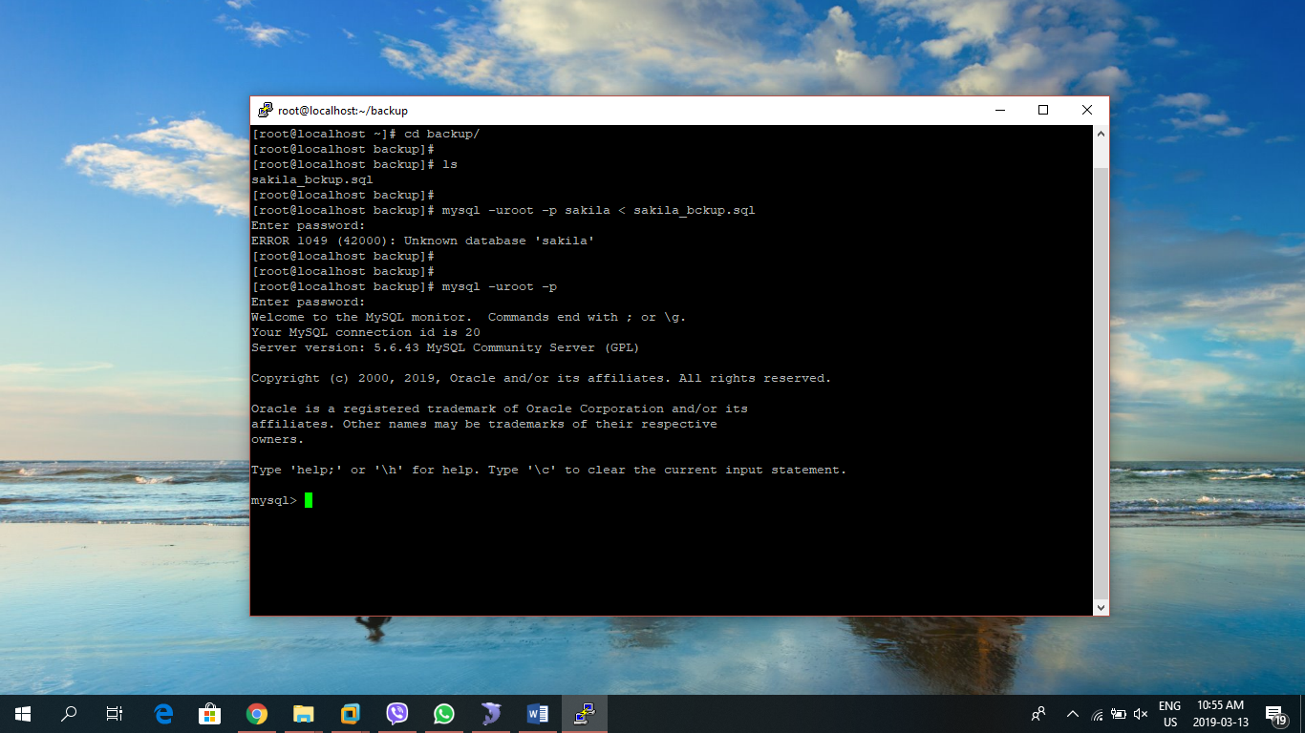
2. Create the database using: **create database sakila;**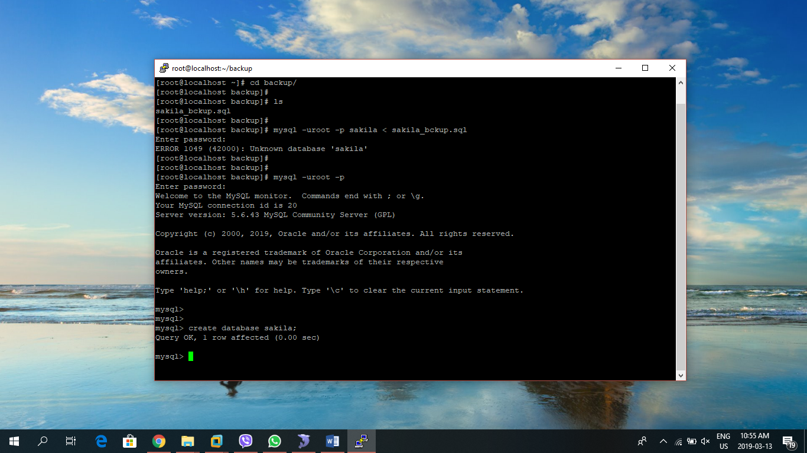
3. Execute **use sakila;** to select sakila database.
4. Execute **show tables;** to view the table list and recently there are no tables present.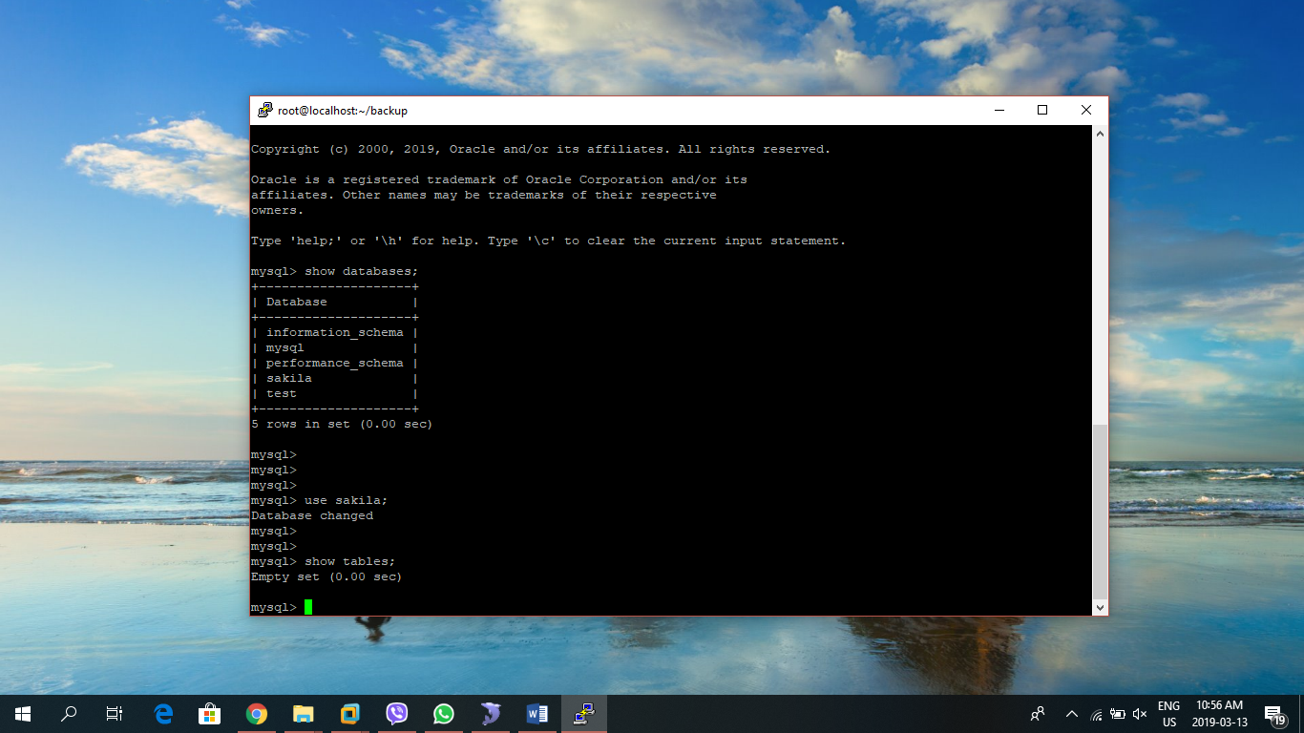
5. Now we can restore the database using the following query: **mysql -uroot -p sakila < sakila_bckup.sql**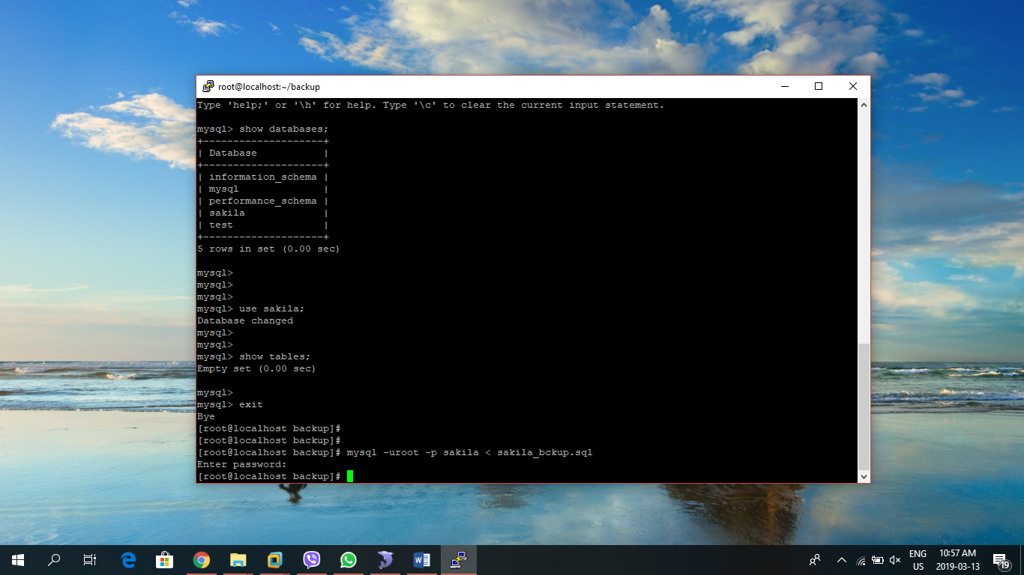
6. To check if the database is successfully restored we can go to mysql command line as a root user and access database sakila and use **show tables;** command to see if the tables are created or not.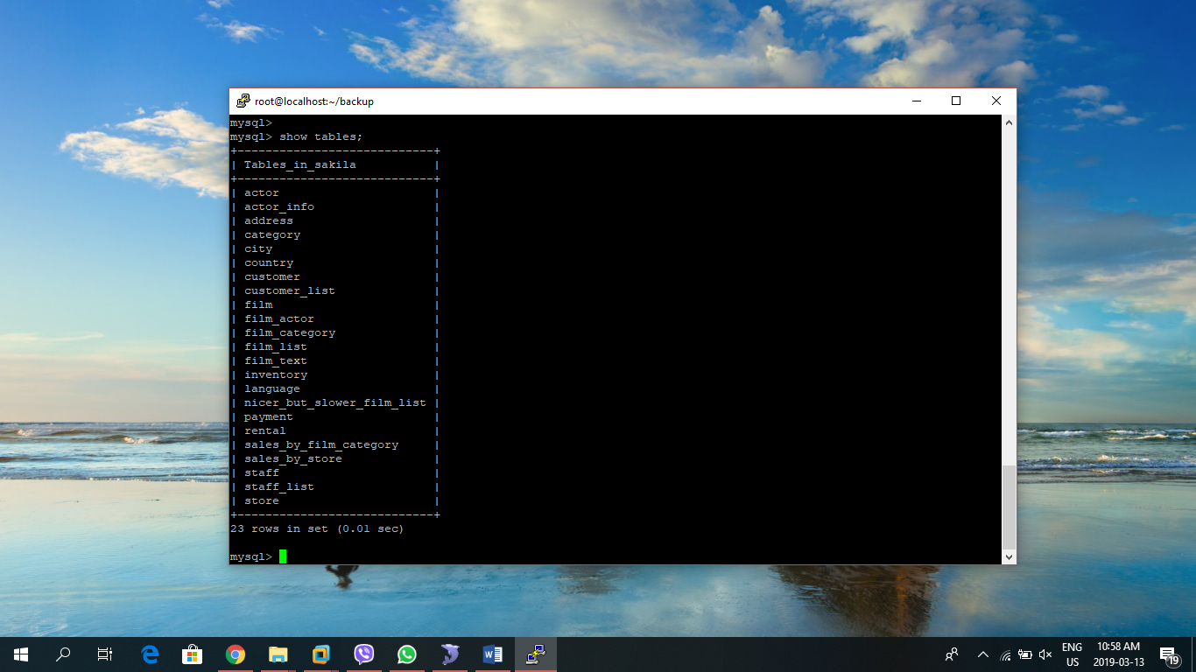
7. We can further check if the data related to the sakila database are successfully restored by selecting data from the table. Use this command: **select * from actor limit 10;**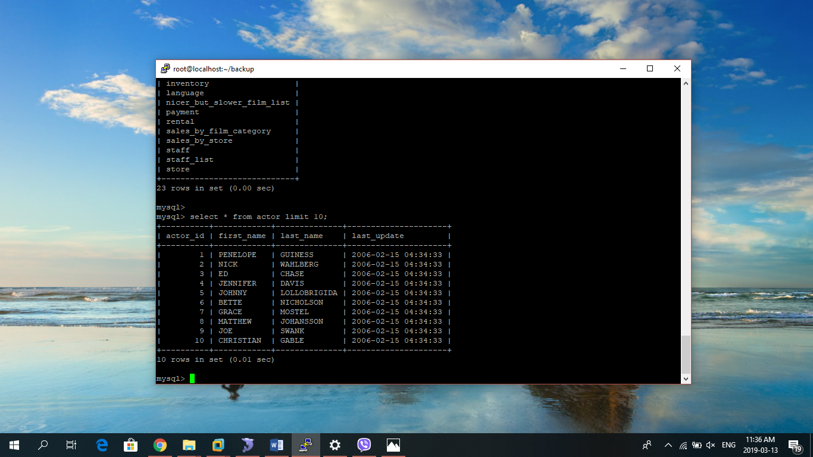
8. Now we can confirm that the database is successfully restored.

### Backup multiple database:

If we want to backup multiple databases just separate database name by the comma as in the following syntax:

**mysqldump -u [username] -p[password] --databases db1 db2 > [dump_file.sql]**

STEPS:

1. We are going to backup two databases named **sakila** and **world**, and dump into a single sql file: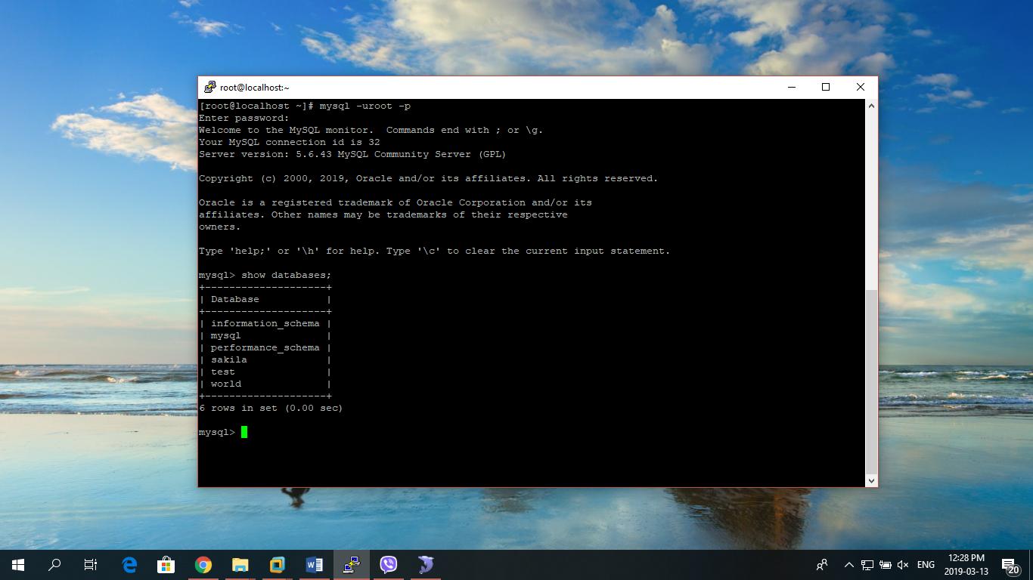
2. Go to directory where you want to create the backup file. I am using directory backup to dump the database.
3. Use the following command to create backup of two databases **sakila** and **world** into a single sql file: **mysqldump -uroot -p --databases sakila world > bckup_sakila_world.sql** 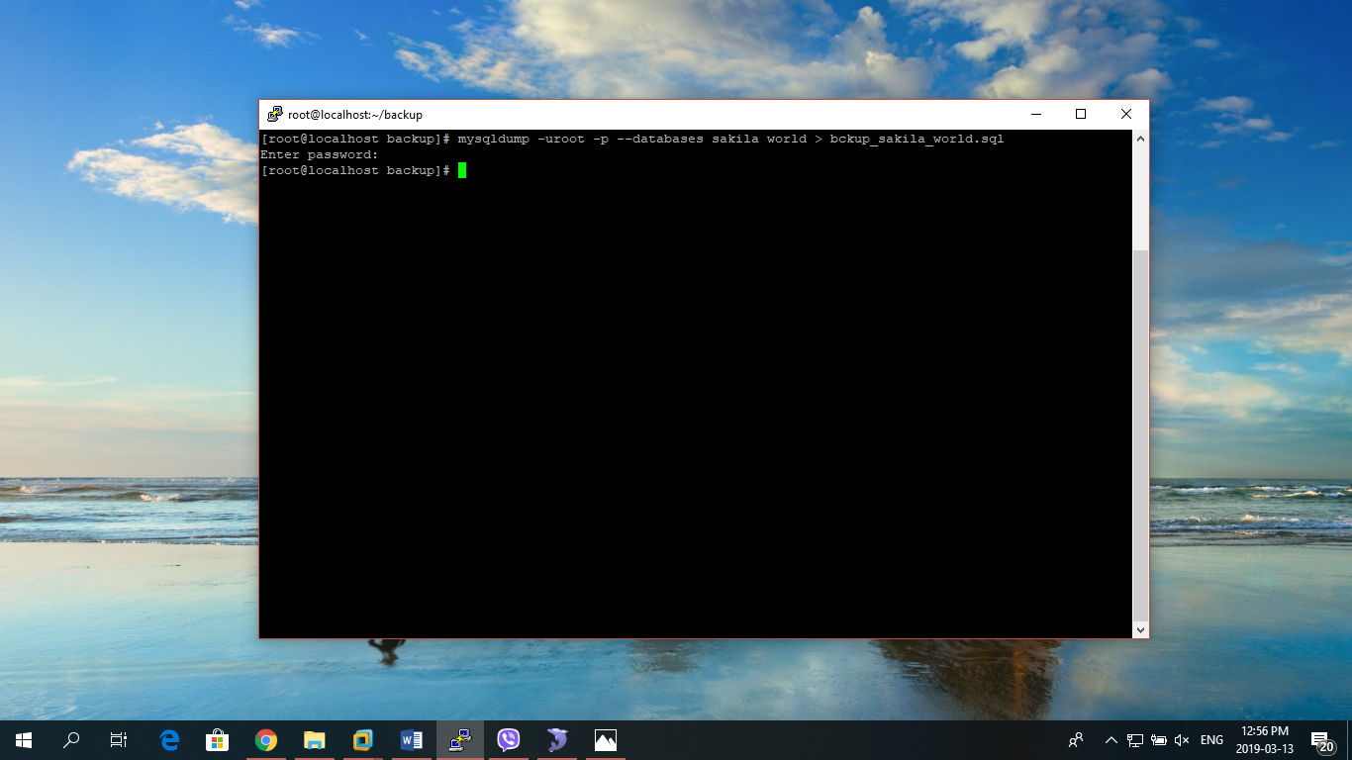
4. Use **ls** command to view the generated backup file: 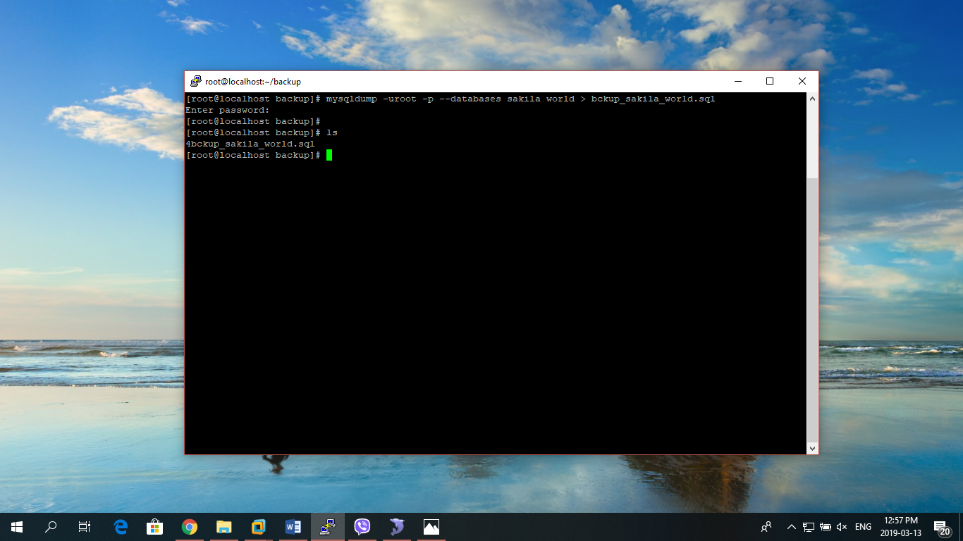
5. We have now successfully created a single backup file for two databases sakila and world.

### Restore multiple database

STEPS

1. Let us verify there are no databases named sakila and world in the server: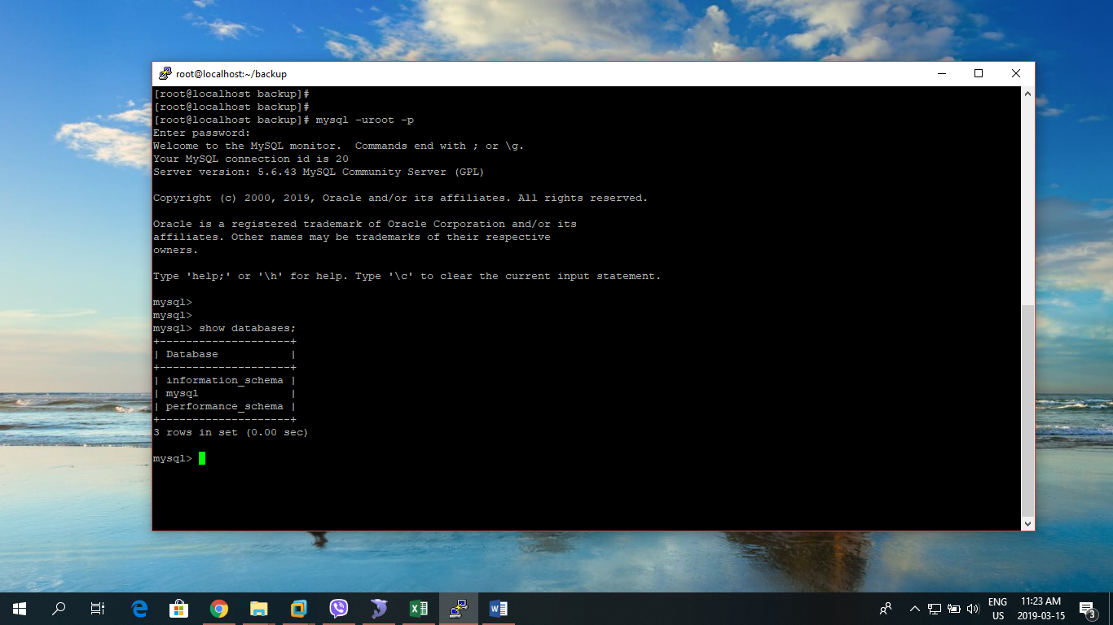
2. Move to the directory backup where our backup file is present using: **cd backup/** 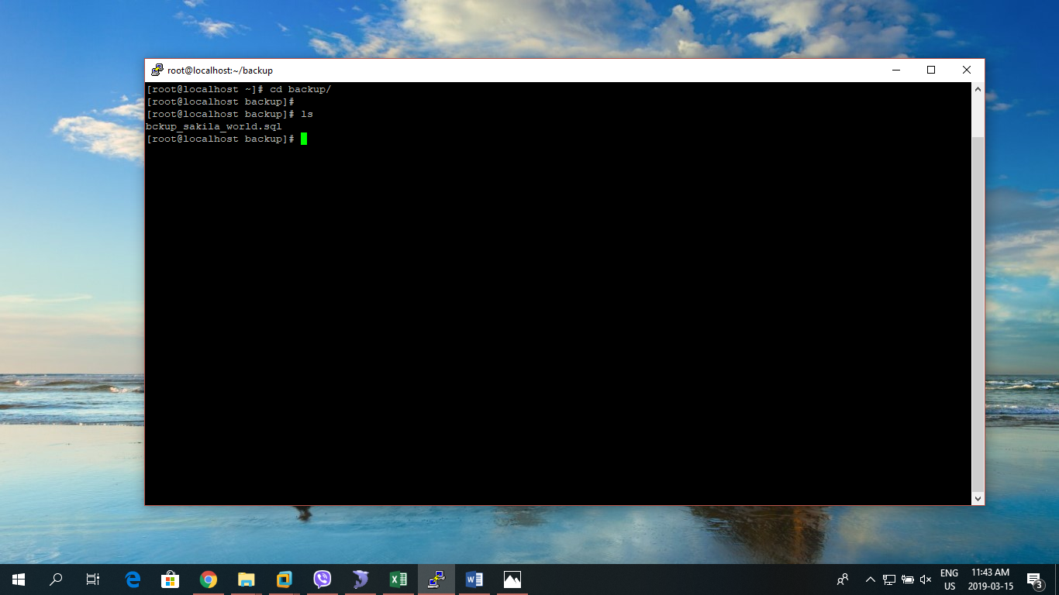

NOTE: First of all, we should create dummy databases named sakila and world before restoring.

1. Now to create the database,first login to mysql using root: **mysql -uroot -p**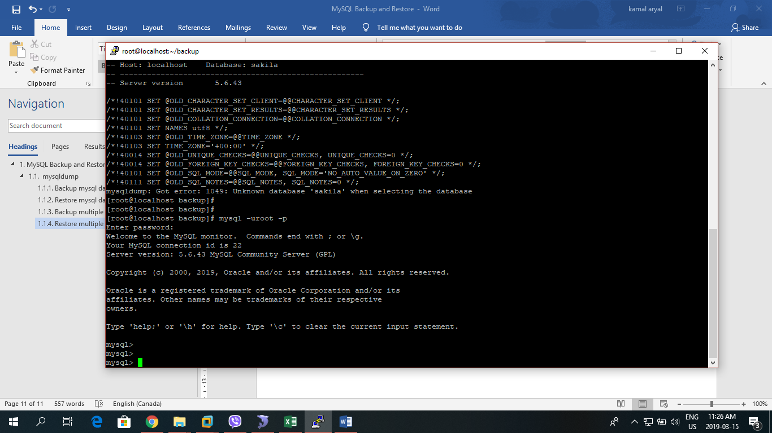
2. Create the sakila database using: **create database sakila;**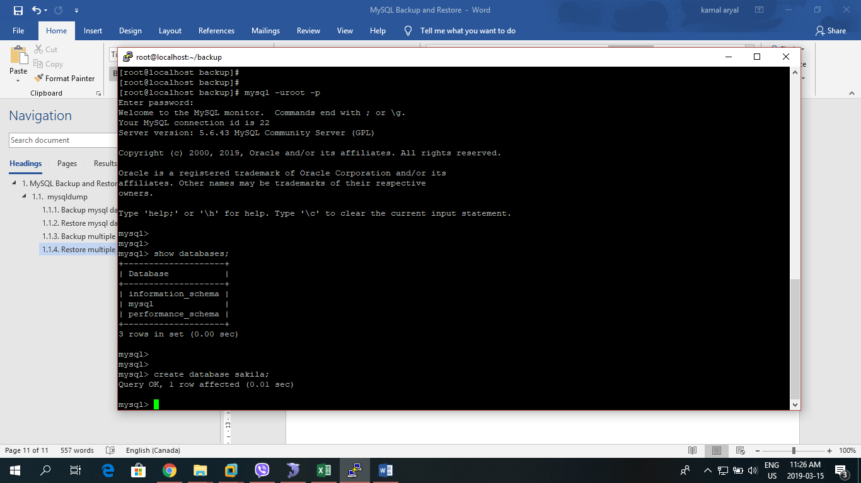
3. Create world database using: **create database world;**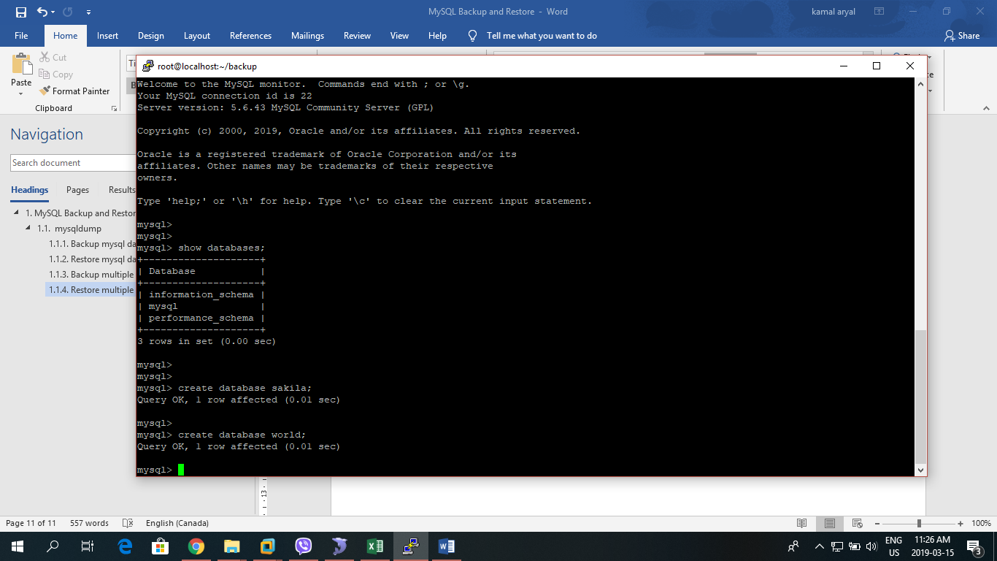
4. Now we can restore the databases using the following query: **mysql -uroot -p < bckup_sakila_world.sql**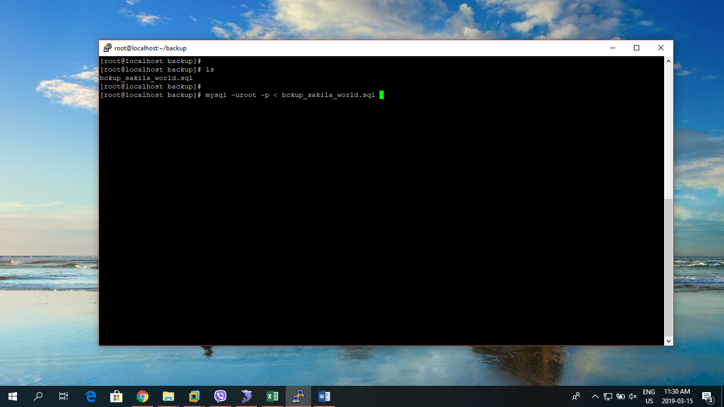
5. To check if the databases are successfully restored, we can login to mysql using root and use sakila database first.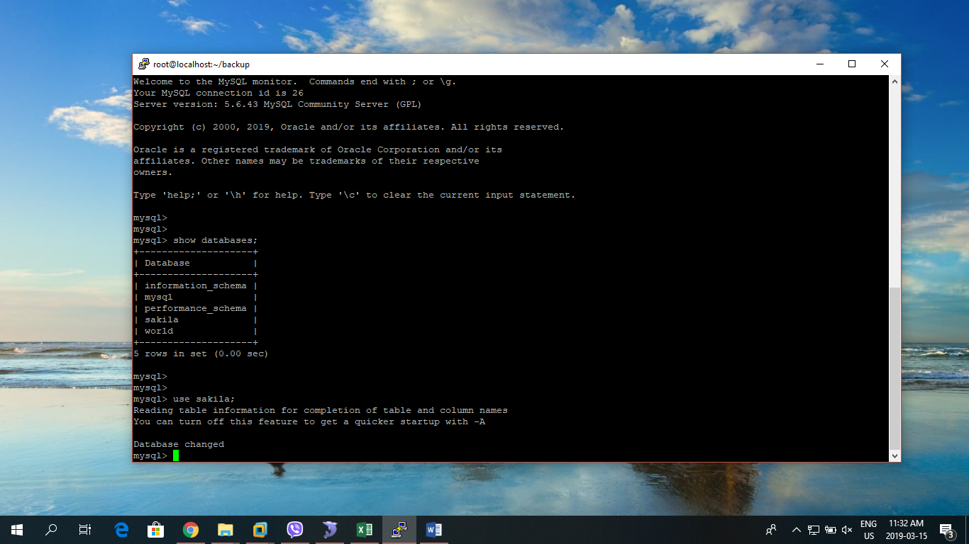
6. Use this command: **select * from actor limit 10;** to check if the datas are also successfully restored.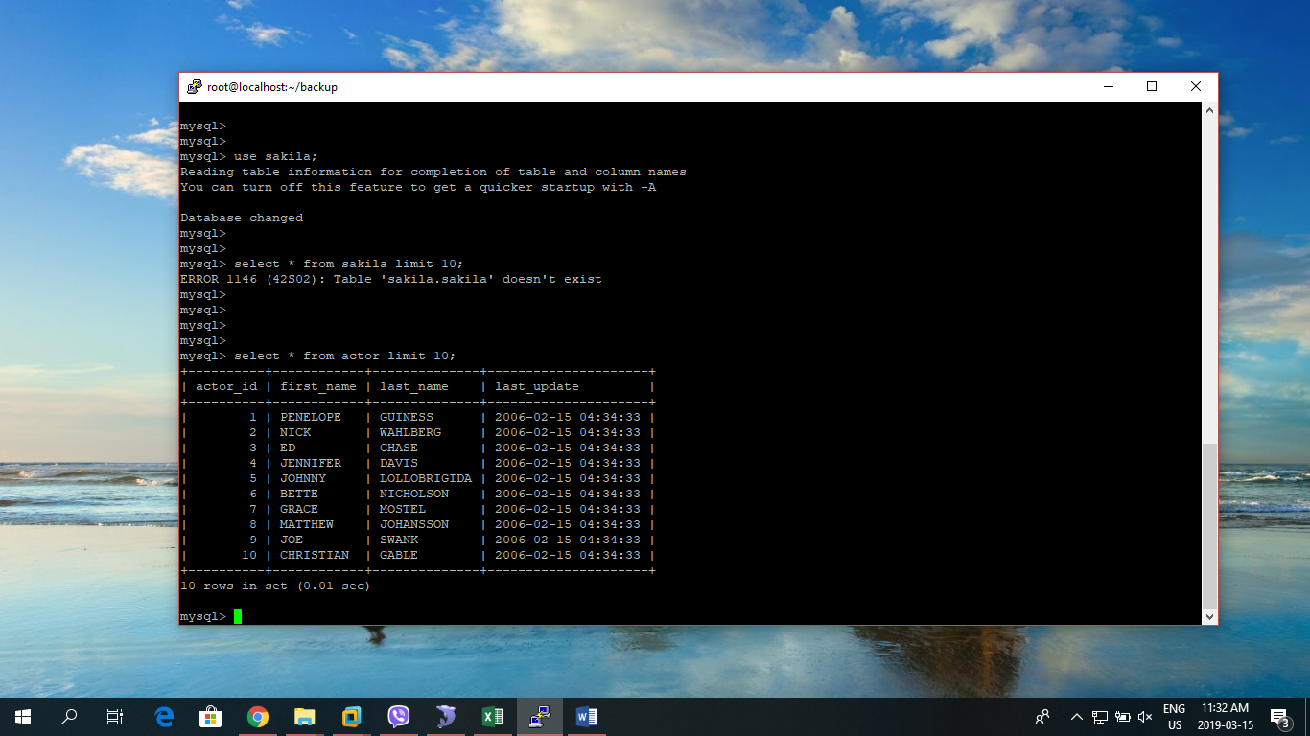
7. Now we can confirm that the database sakila is successfully restored.
8. Similarly, the same process can be done to check if the database world is successfully restored.

## Percona Full/Incremental Hot Backup/Restore

To perform a hot backup of our database, our database system must be using the **InnoDB** storage engine. This is because Percona XtraBackup relies on the transaction log that InnoDB maintains.

### Percona Full Hot Backup

STEPS:

1. First, enter into the mysql console as a root user using: **mysql -uroot -p**

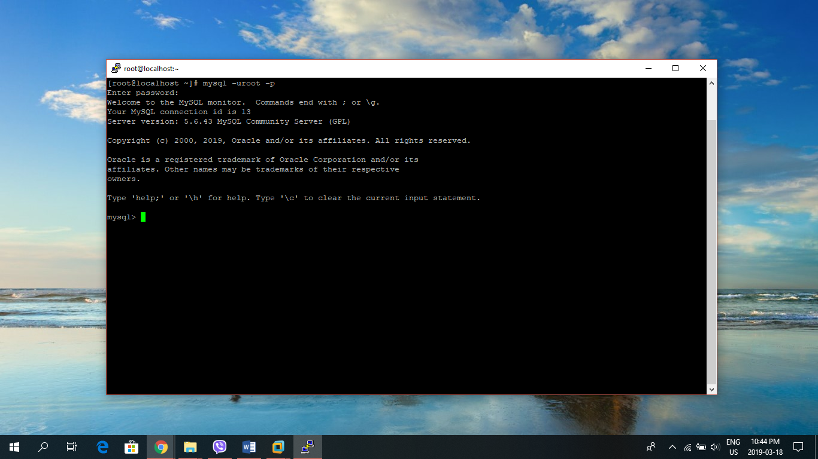

1. At MySQL prompt, select the desired database you want to check the storage engine type using: **USE db_name;** 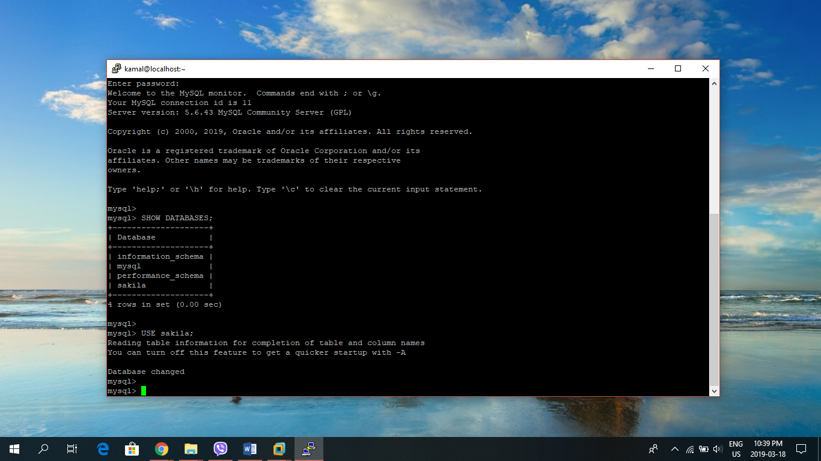
2. Then print the table statuses using: **SHOW TABLE STATUS\G;**

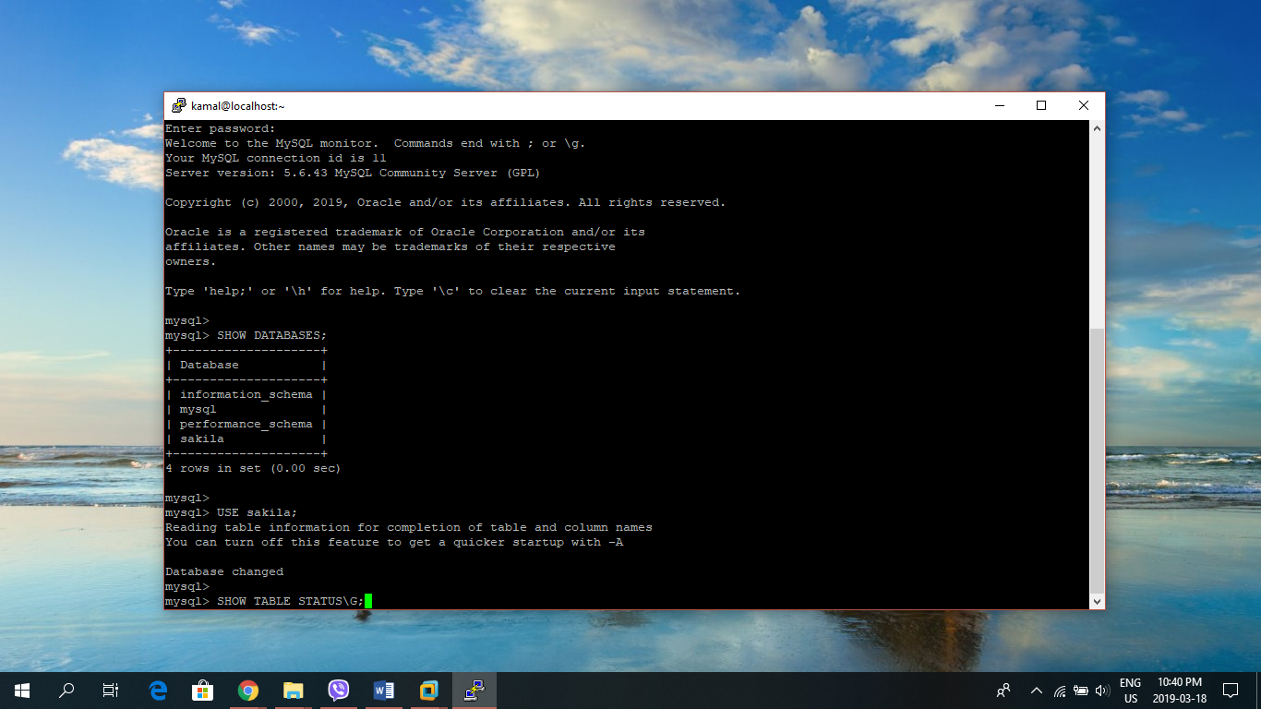

1. We can look the Engine Type. Here it is InnoDB 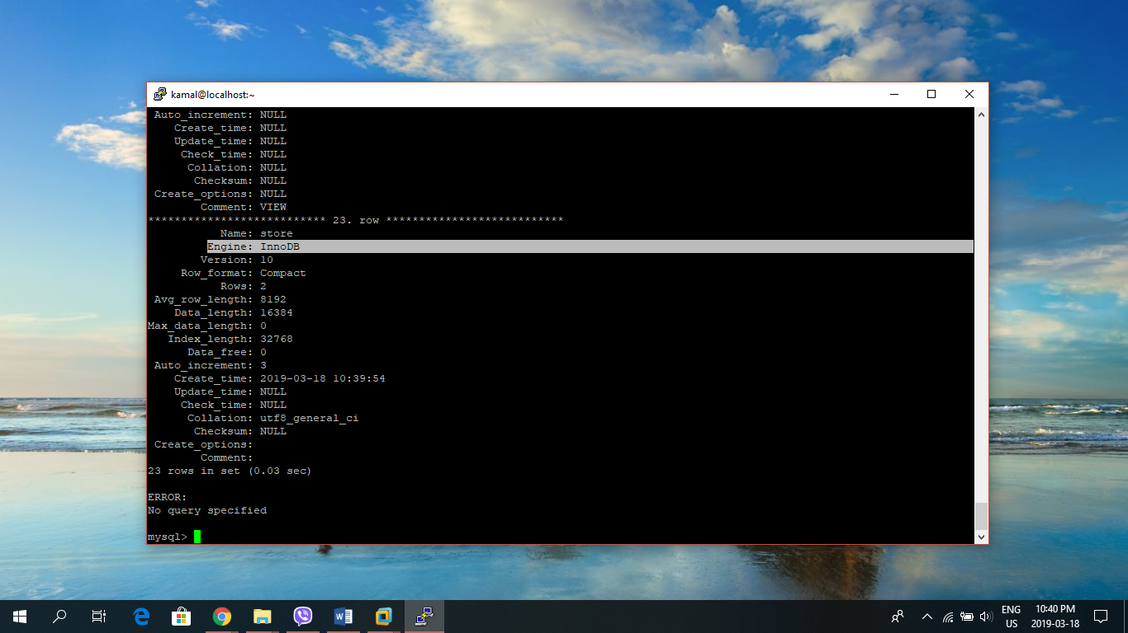
2. Since the storage engine type of our database is InnoDB, we can now install Percona XtraBackup for full/incremental hot backup. The easiest way to install Percona XtraBackup is to use **yum**, as Percona’s repository provides RPM: **sudo yum install** [**http://www.percona.com/downloads/percona-release/redhat/0.1-3/percona-release-0.1-3.noarch.rpm**](http://www.percona.com/downloads/percona-release/redhat/0.1-3/percona-release-0.1-3.noarch.rpm) 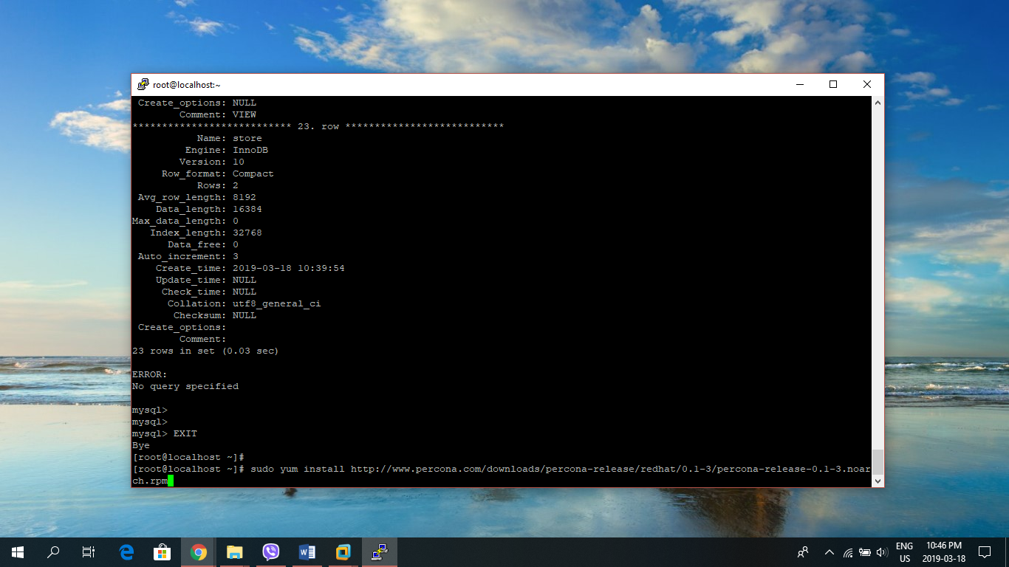
3. Then we can run the following command to install Percona XtraBackup: **sudo yum install percona-xtrabackup** 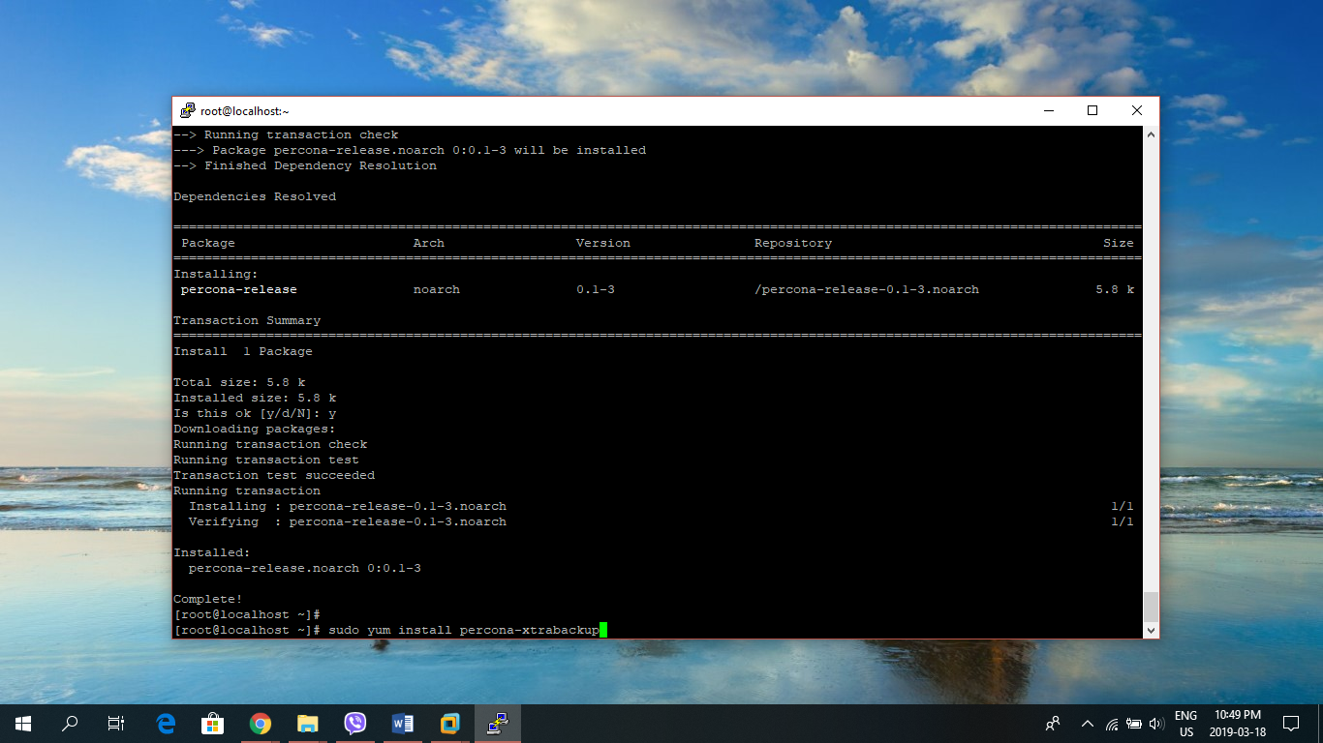
4. We must perform some basic preparations to ensure that XtraBackup can be executed properly. Let us suppose that you are logged in as the user that will run XtraBackup, and that it has superuser privileges.
5. Add system user to the “mysql” group (substitute actual username, mine is kamal): **sudo gpasswd -a username mysql** 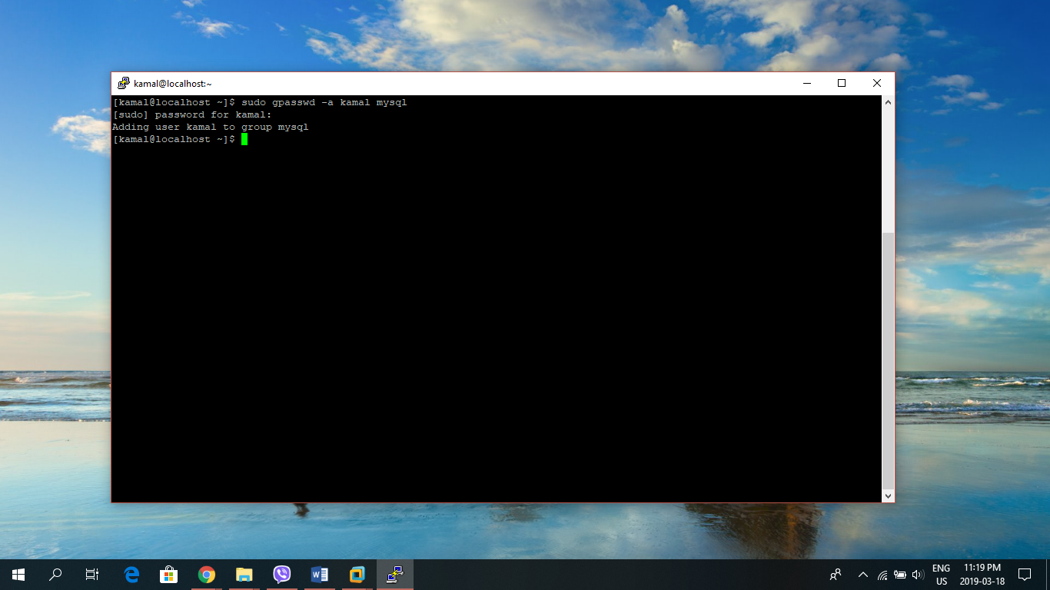
6. Let’s create the directory that will be used for storing the backups that XtraBackup creates:

**$** **sudo mkdir -p /data/backups**

**$ sudo chown -R username: /data**

The **chown** command ensures that the user will be able to write to the backup’s directory. 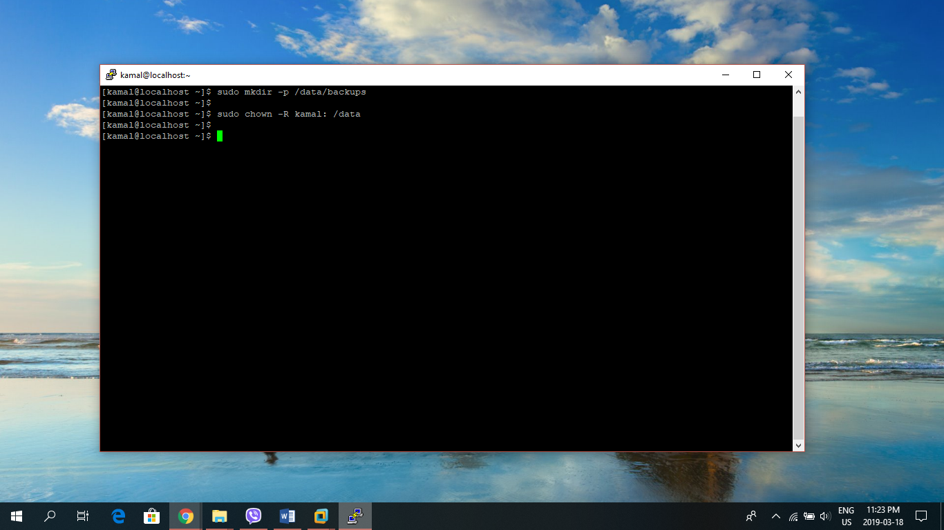

1. XtraBackup requires a MySQL user when creating backups. To create the user, first let us enter into the MySQL console using **mysql -uroot -p**. At the MySQL prompt, create a new MySQL user and assign it a password using: **CREATE USER ‘bkpuser’@‘localhost’ IDENTIFIED BY ‘bkppassword’;** (use appropriate user name and password) 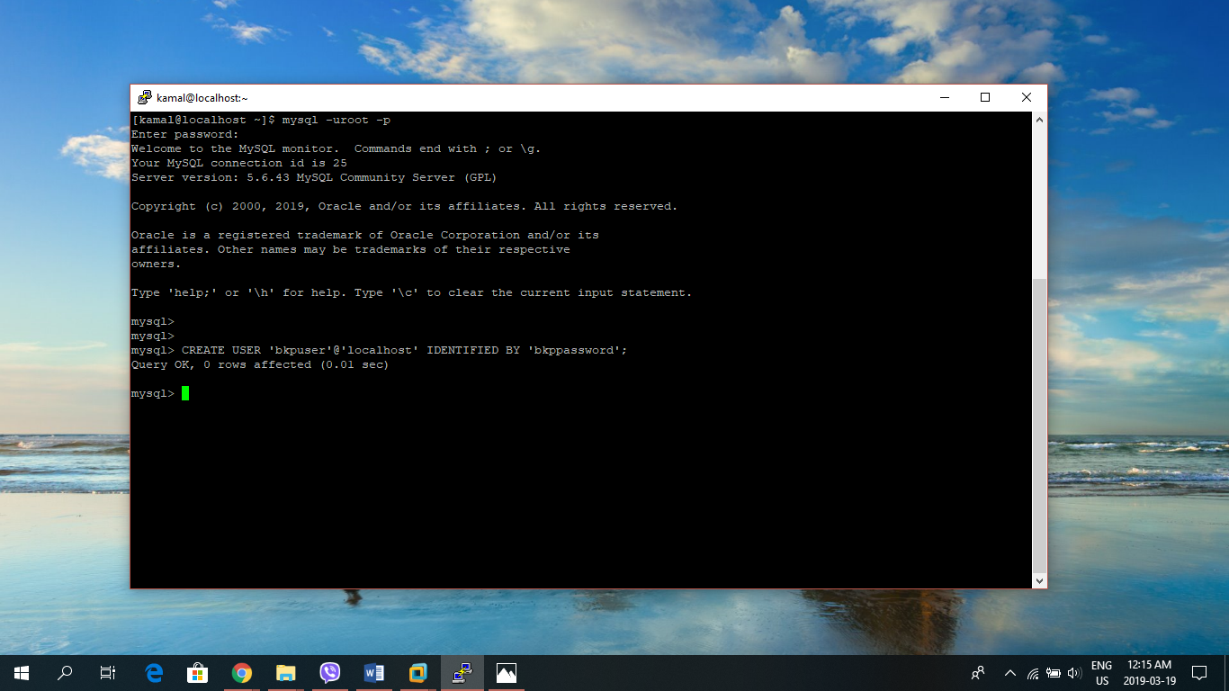
2. Now, grant the new MySQL user reload, lock, and replication privileges to all of the databases:

* **GRANT RELOAD, LOCK TABLES, REPLICATION CLIENT ON *.* TO ‘bkpuser’@‘localhost’;**
* **FLUSH PRIVILEGES;** 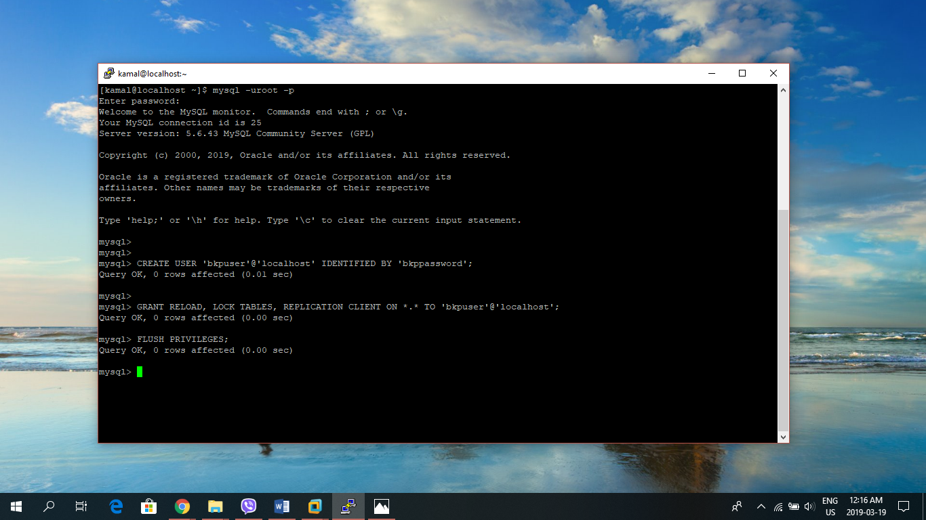

1. These are the minimum required privileges that XtraBackup needs to create full backups of databases. When finished, exit the MySQL console.
2. Update Datadir Permissions: On CentOS 7, MySQL's data files are stored in **/var/lib/mysql**, which is sometimes referred to as a **datadir**. By default, access to the datadir is restricted to the mysql user. XtraBackup required access to this directory to create its backup, so to ensure that the system user we set up earlier-as a member of the mysql group-has the proper permissions let us execute the following commands:

**$ sudo chown -R mysql: /var/lib/mysql**

**$ sudo find /var/lib/mysql -type d -exec chmod 775 “{}” \;** 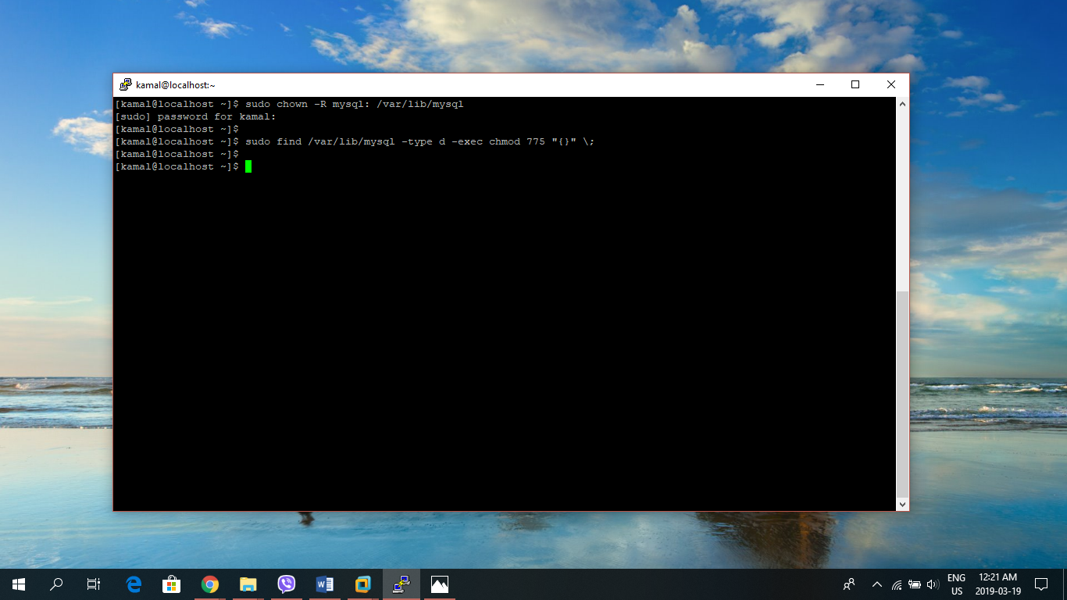

These commands ensure that all of the directories in the datadir are accessible to the mysql group, and should be run prior to each backup.

1. Now we are ready to create the backup. With the MySQL database running, use the **innobackupex** utility to do so:

$ **innobackupex --user=bkpuser --password=bkppassword /data/backups** 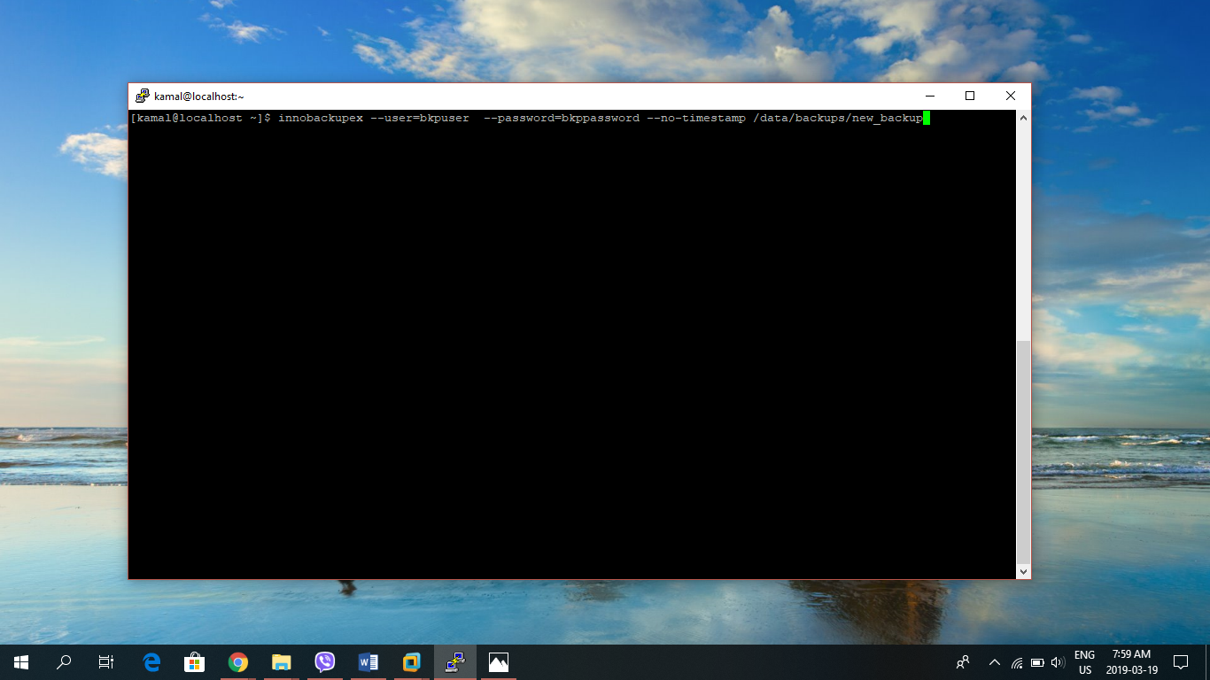

1. Check **Completed Ok** to confirm the successful backup of the databases. 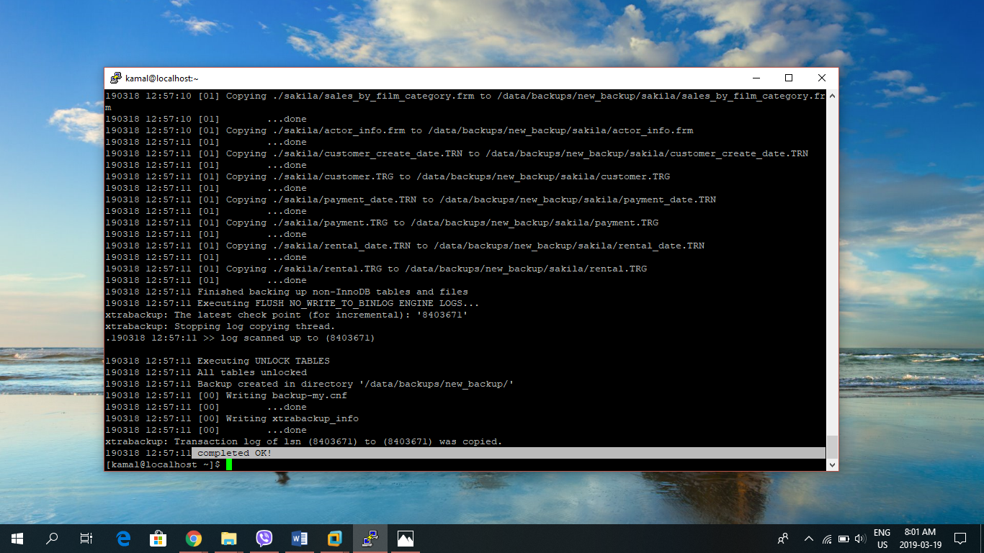
2. Apply transaction log using: **innobackupex –apply-log /data/backups/new_backup** 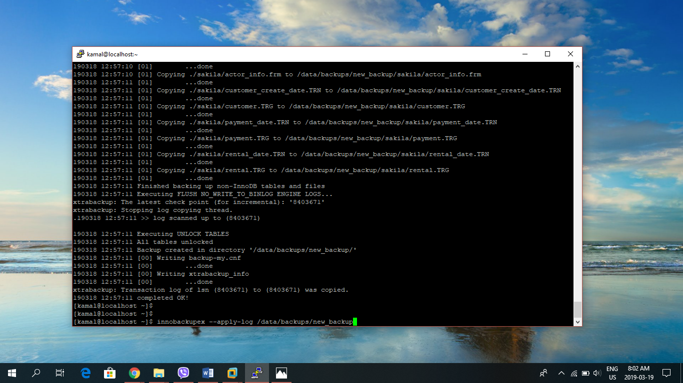
3. Check for **Completed Ok** to ensure transaction log are executed properly 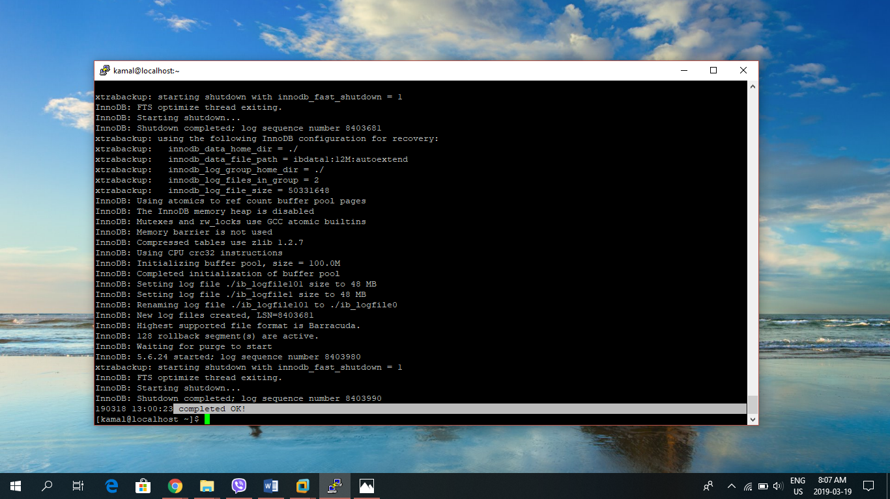
4. We have now successfully create backup of our databases using Percona XtraBackup.

### Performing Backup Restoration

Restoring a database with XtraBackup requires that the database is stopped, and that its datadir is empty

STEPS:

1. Stop the MySQL service by using: **service mysqld stop** 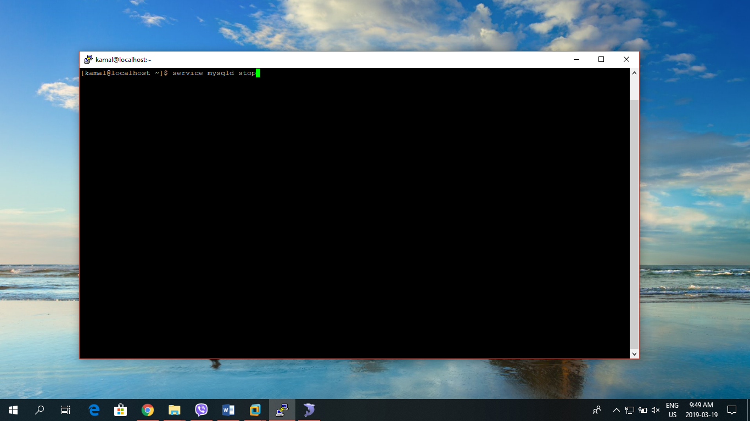
2. Then move or delete the contents of the datadir (/var/lib/mysql). Here, let us simply move it to temporary location using:

**$ mkdir /tmp/mysql**

**$ mv /var/lib/mysql/* /tmp/mysql/** 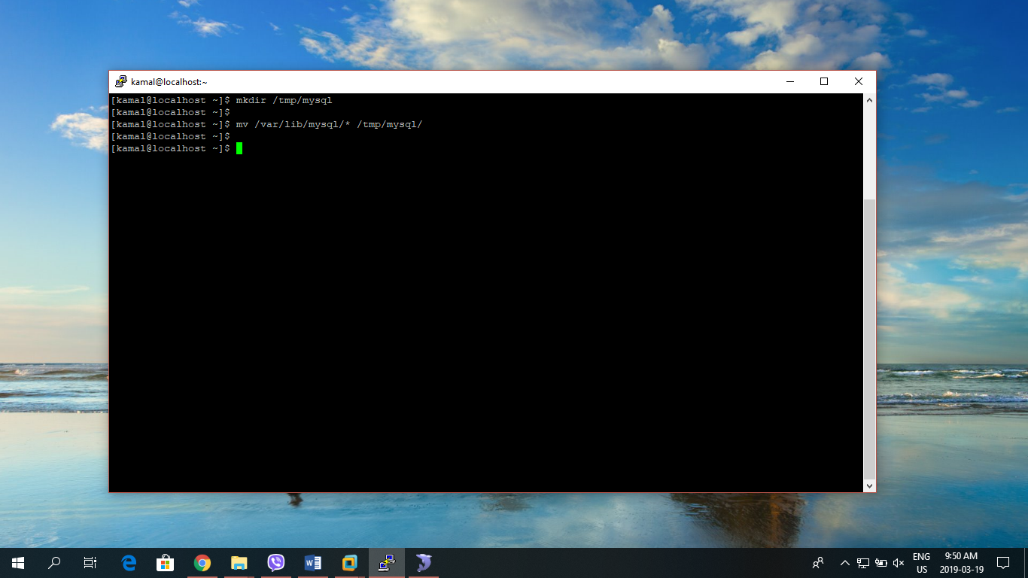

1. Now we can restore the database from our backup, **new_backup** using: **innobackupex –copy-back /data/backups/new_backup** 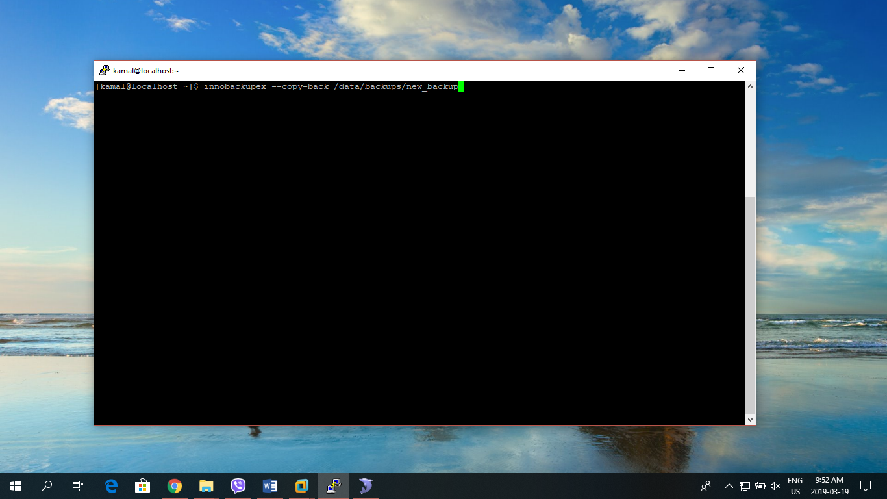
2. Check **completed OK!** status at the end of the execution to verify the successful backup 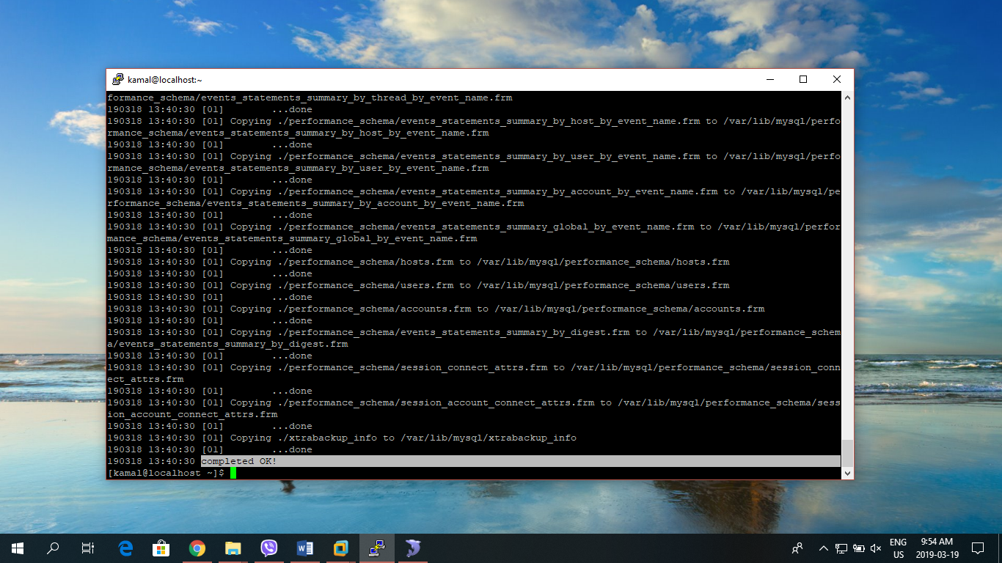
3. The restored files in datadir will probably belong to the user we ran to restore process as. Let us change the ownership back to mysql, so mysql can read and write files: **sudo chown -R mysql: /var/lib/mysql** 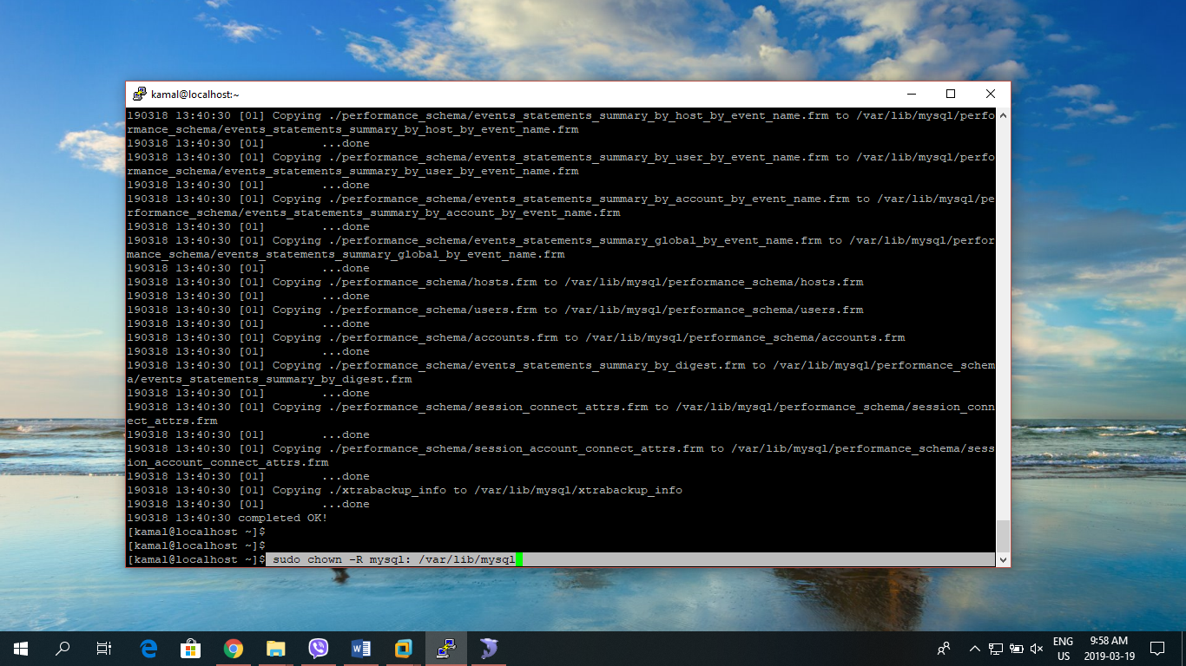
4. Now we are ready to start the mysql: **sudo service mysqld start** 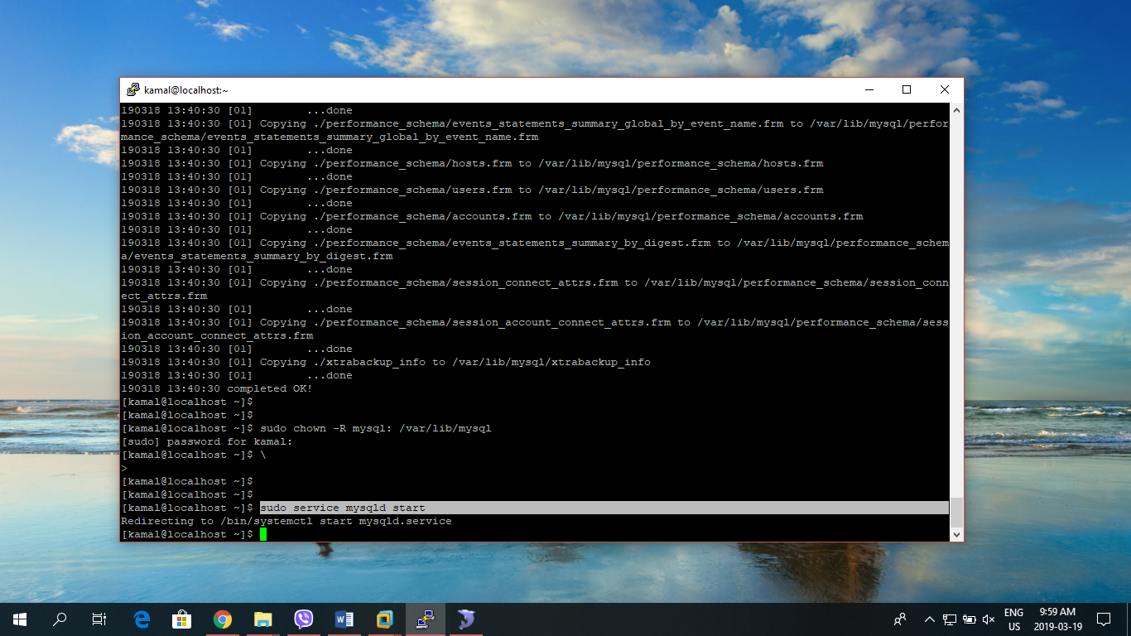

### Performing Percona Incremental Backup

STEPS:

1. Every incremental backup starts with a full one, which we will call the **base backup**:

**$ innobackupex --user=bkpuser --password=bkppassword --no-timestamp /data/backups/sun** 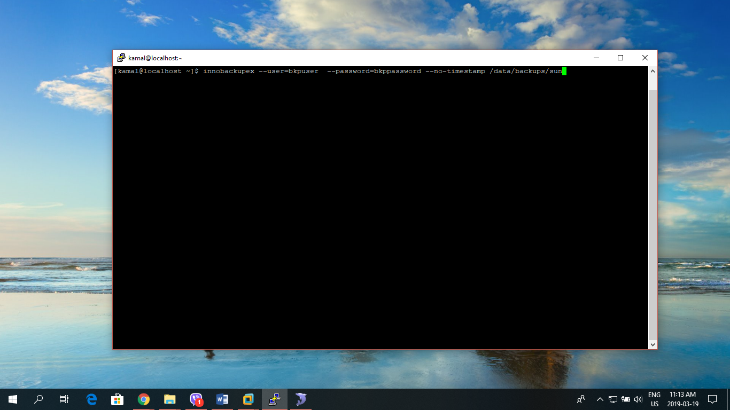

1. Full Backup performed succesfully with timestamps: 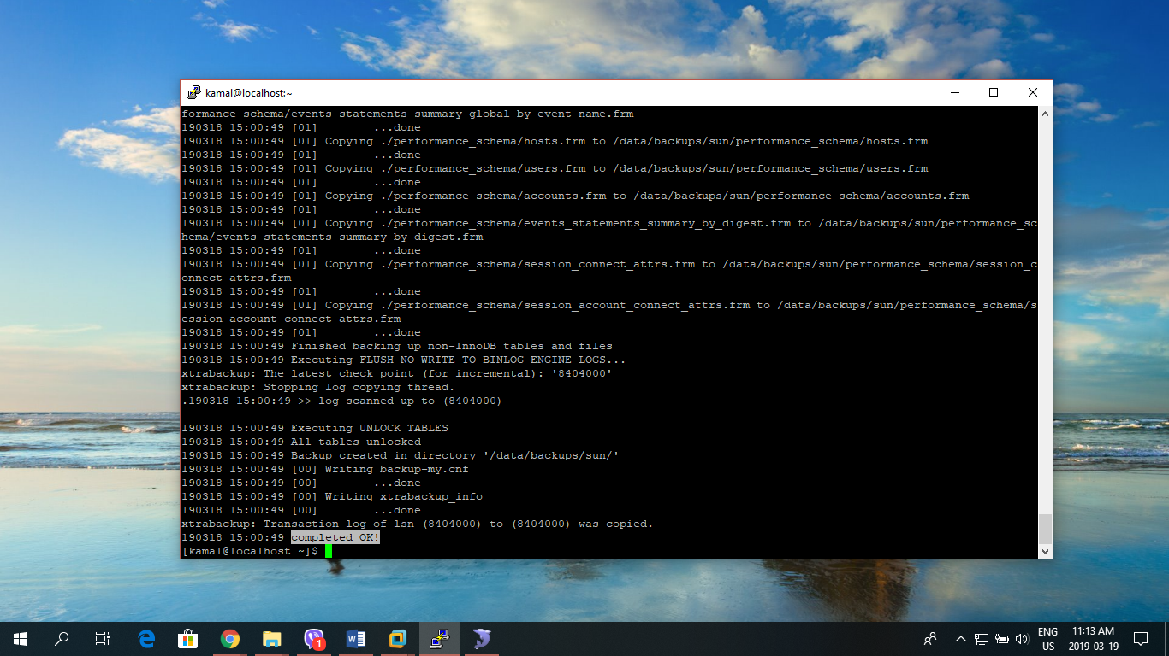
2. Let’s do an incremental backup using:

**$** **innobackupex --incremental /data/backups/mon/ --incremental-basedir=/data/backups/sun/ --user=bkpuser --password=bkppassword** 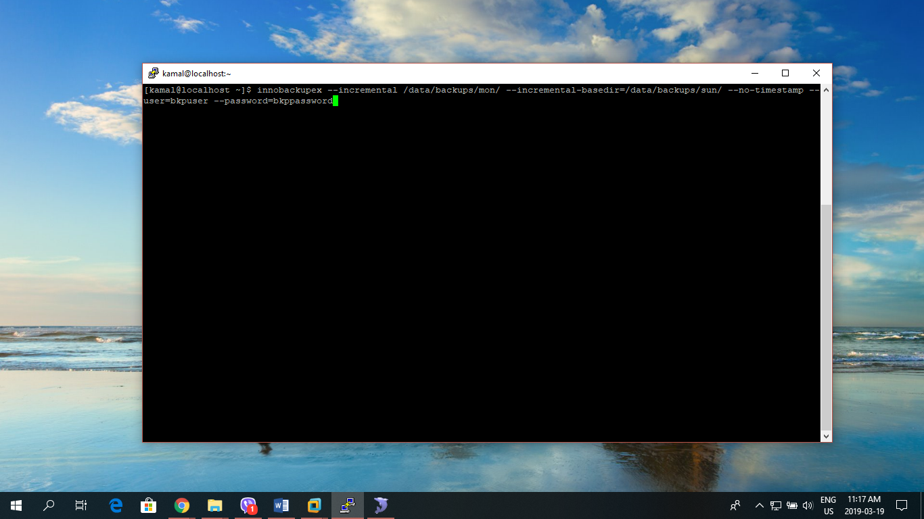

1. Check for completed OK! to ensure that incremental backup is taken successfully. 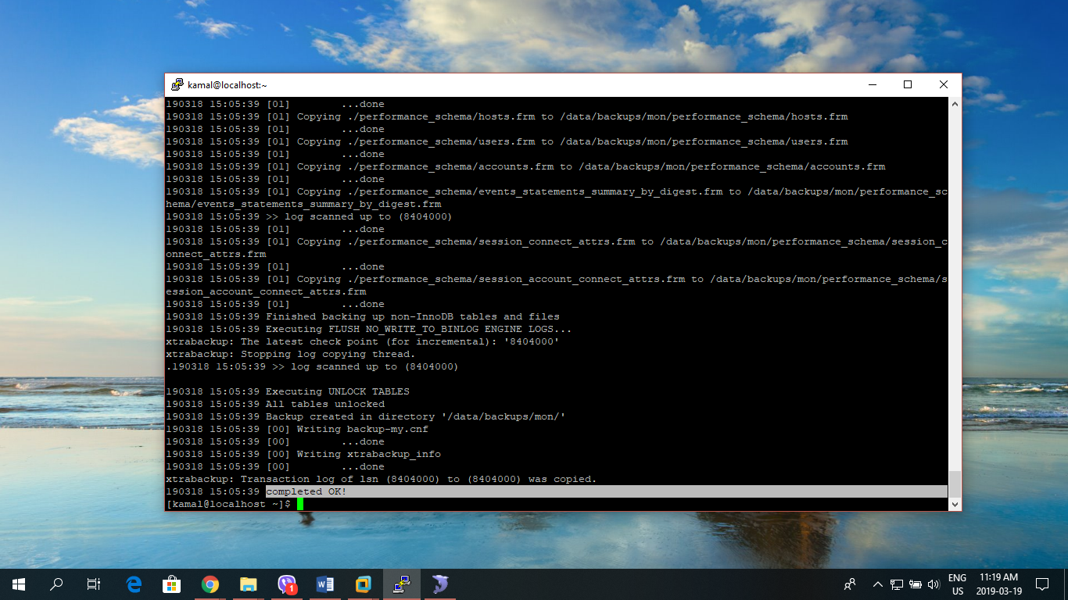

### Preparing Restoration of Percona Incremental Backup

STEPS:

1. First, let’s us apply incomplete transaction log to the full backup using: **innobackupex --apply-log --redo-only /data/backups/sun/ --user=bkpuser –password=bkppassword**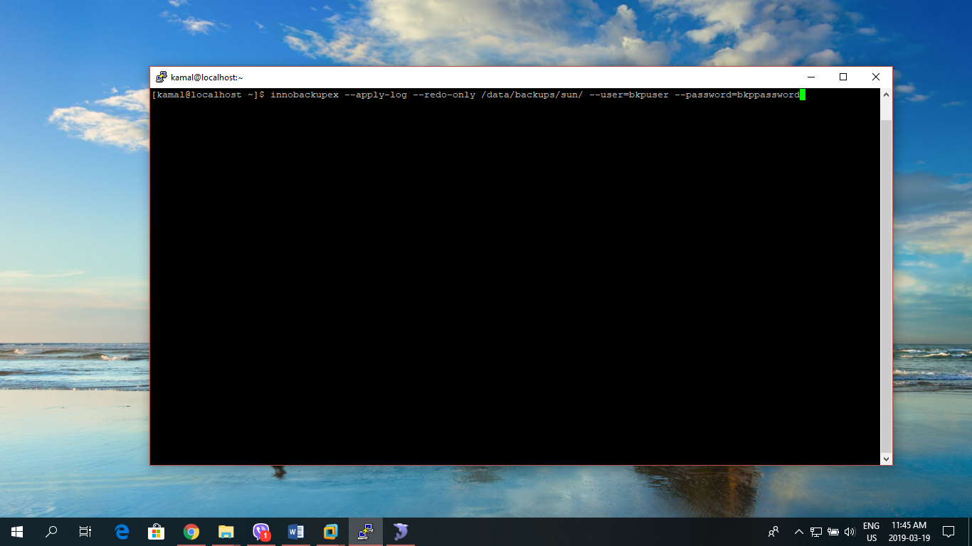
2. Check complete OK! for successful execution: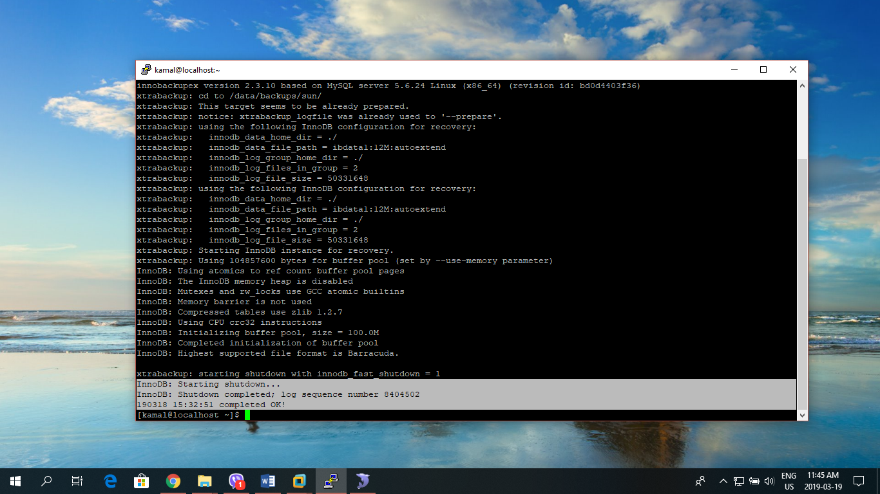
3. Now, add the incremental taken on Monday using: **innobackupex --apply-log --redo-only /data/backups/sun/ --incremental-dir=/data/backups/mon/**

**--user=bkpuser –password=bkppassword**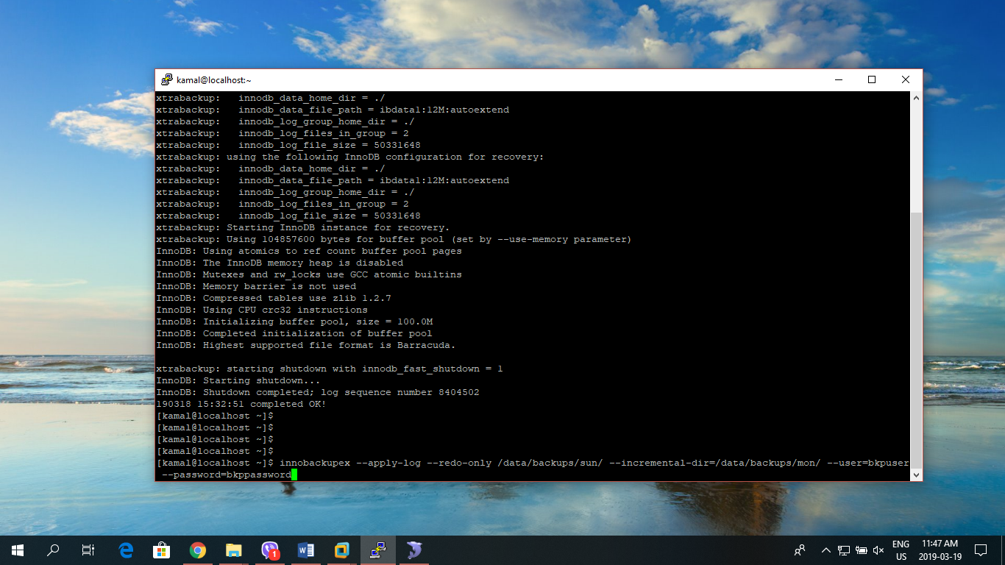

1. Check for completed OK! for successful execution: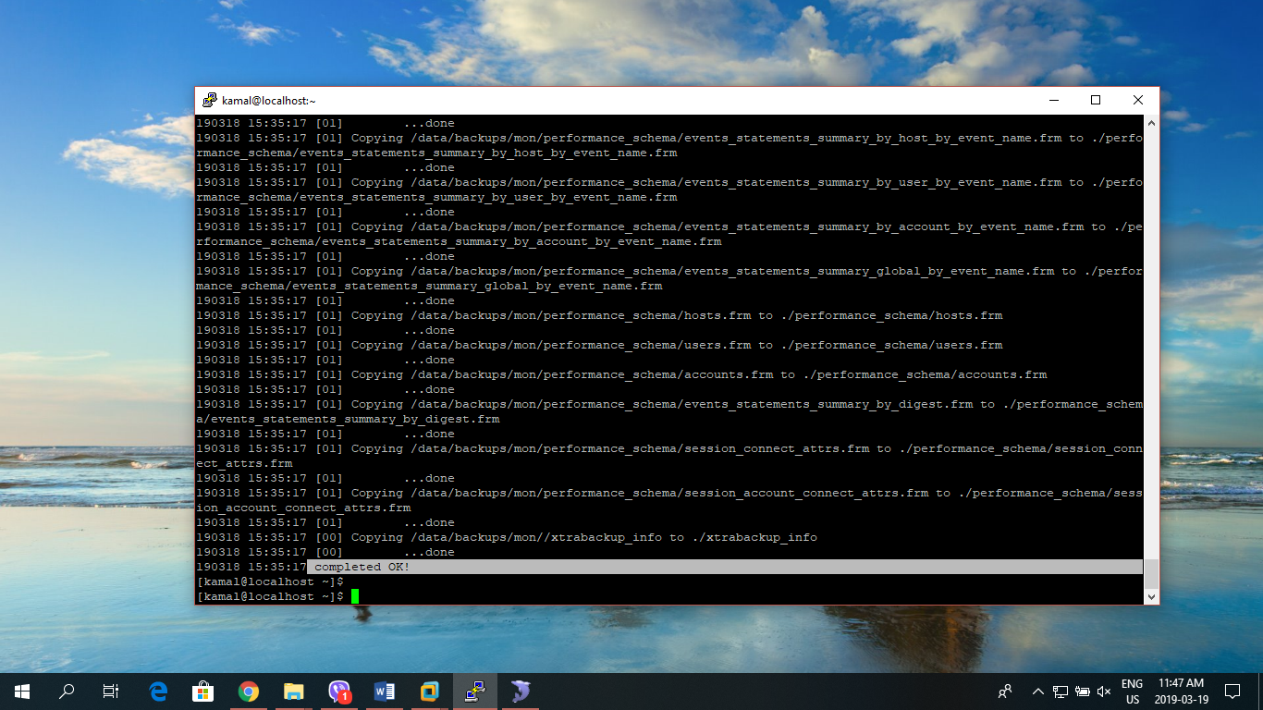
2. Once you put all the parts together, you can prepare again the full backup (base + incrementals) once again to rollback the pending transactions:

**innobackupex --apply-log /data/backups/sun/**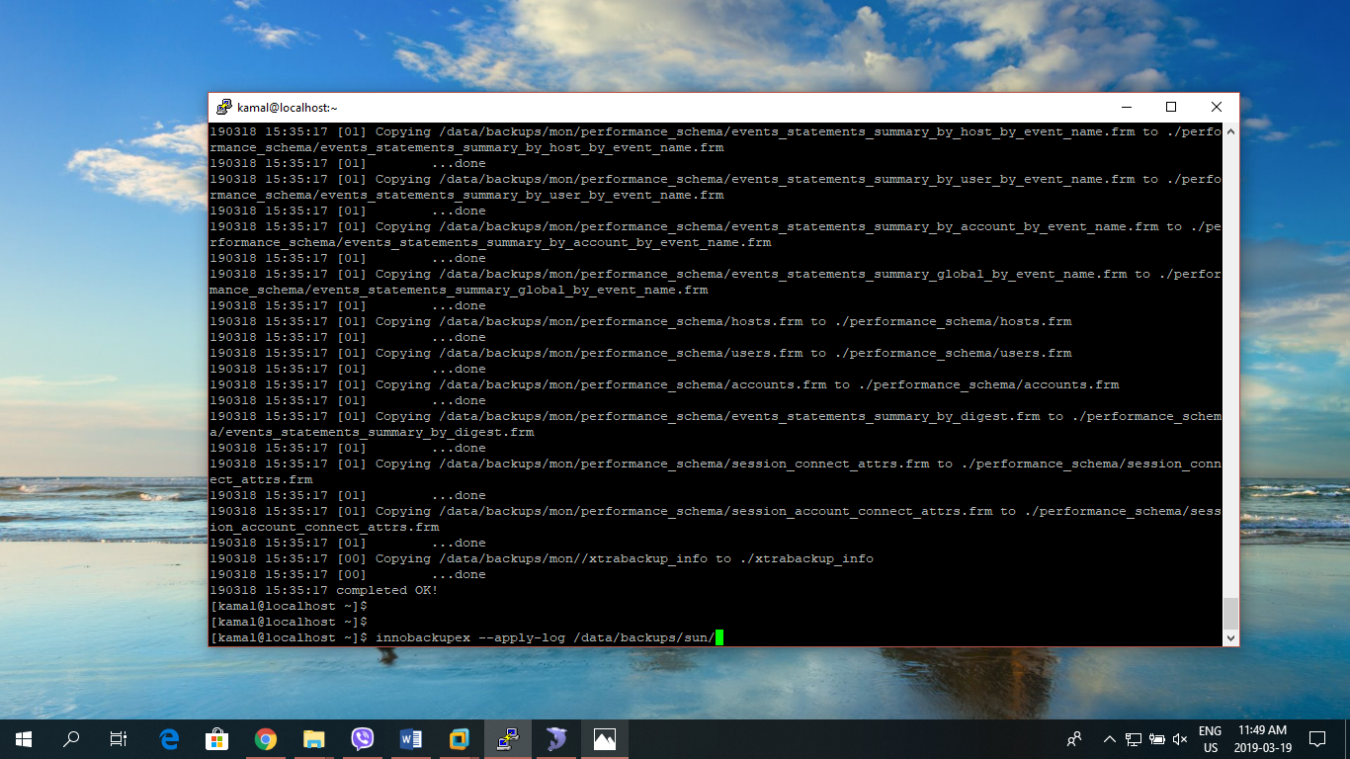

1. Check for completed OK! for successful execution: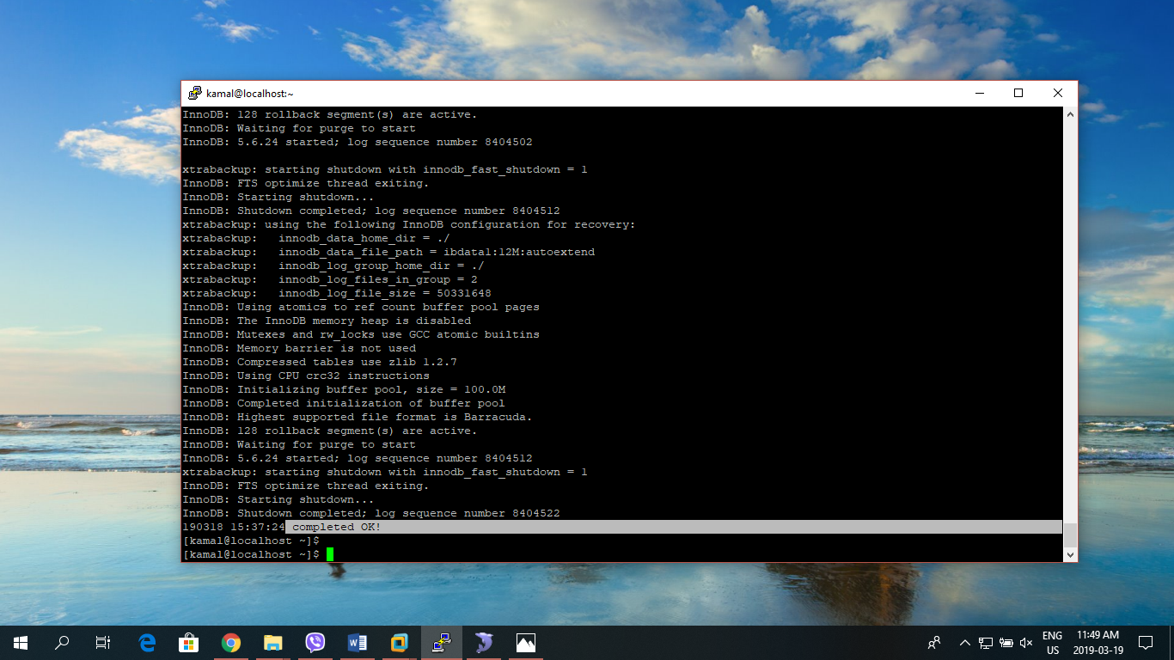

**IMPORTANT: If you want to apply more incremental backups, repeat this step with the next one. It is important that you do this in the chronological order in which the backups were done.**

1. Now preparation for restoration of backup file is completed. Simply follow **Section 1.2.2.** for restoration of backup database.

**NOTE**: Incremental backups work because each InnoDB page contains a **log sequence number**, or LSN. The LSN is the system version number for the entire database. Each page’s LSN shows how recently it was changed.

We can check the file **xtrabackup_checkpoints** at the directory of each one.

Full Prepared ones:

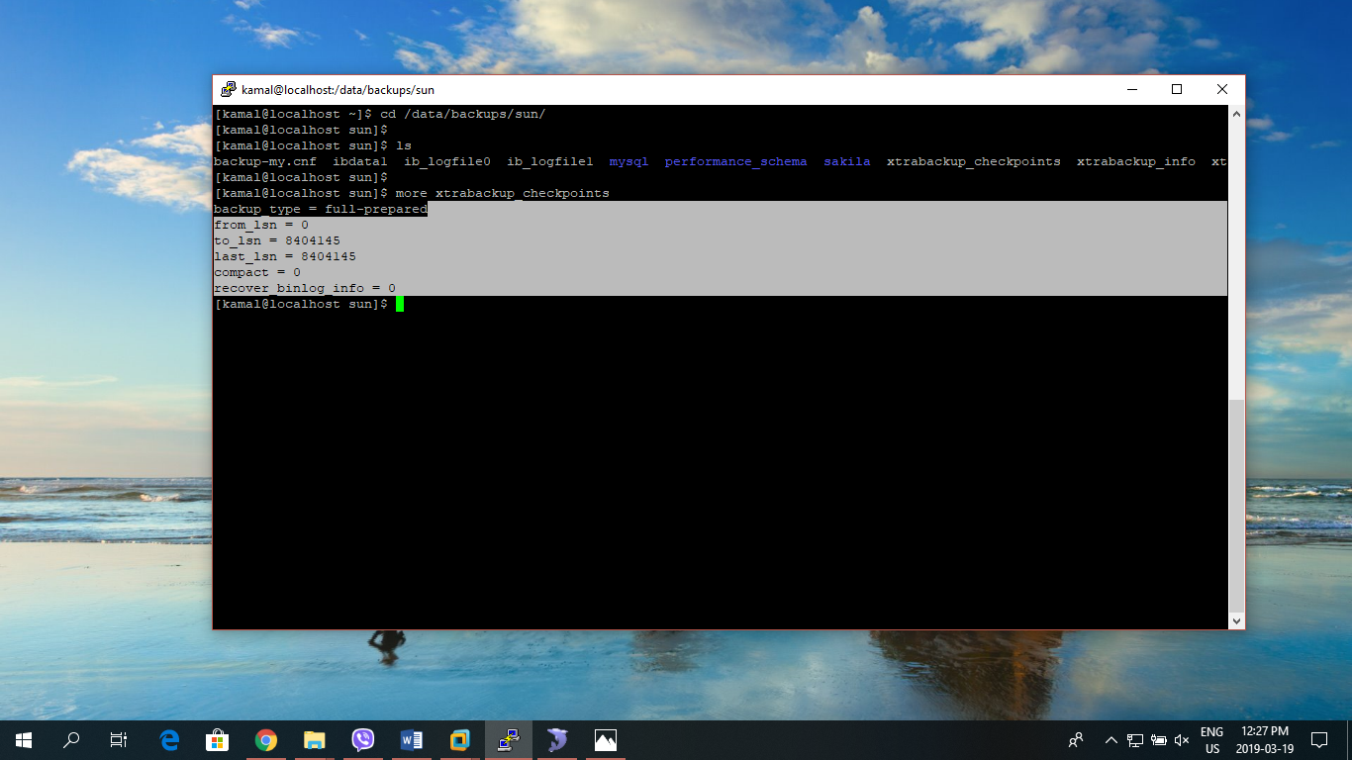

Incremental ones:

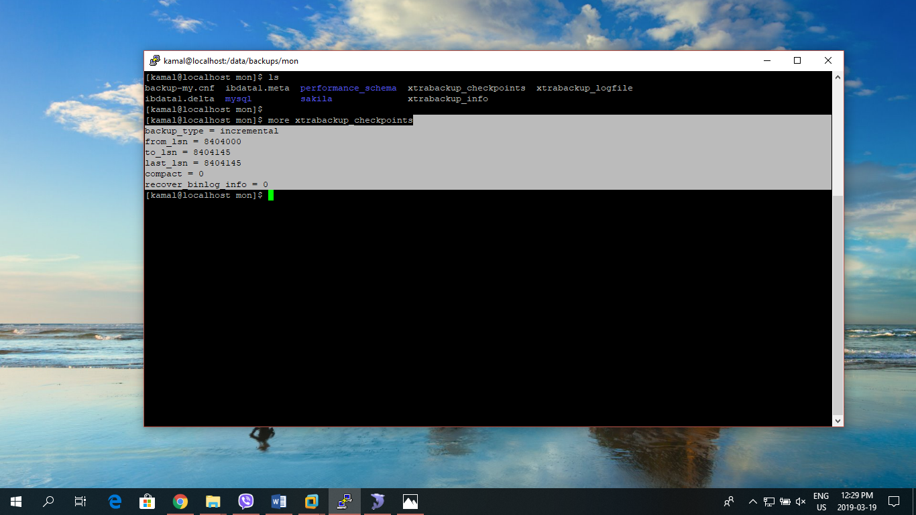

## MySQL Enterprise Backup/Restore

### MySQL Enterprise Backup

STEPS:

1. Download from <https://edelivery.oracle.com/osdc/faces/Home.jspx>
2. Transfer the downloaded file to the server using WinSCP.
3. Use **ls** command to see the transferred file in the server: 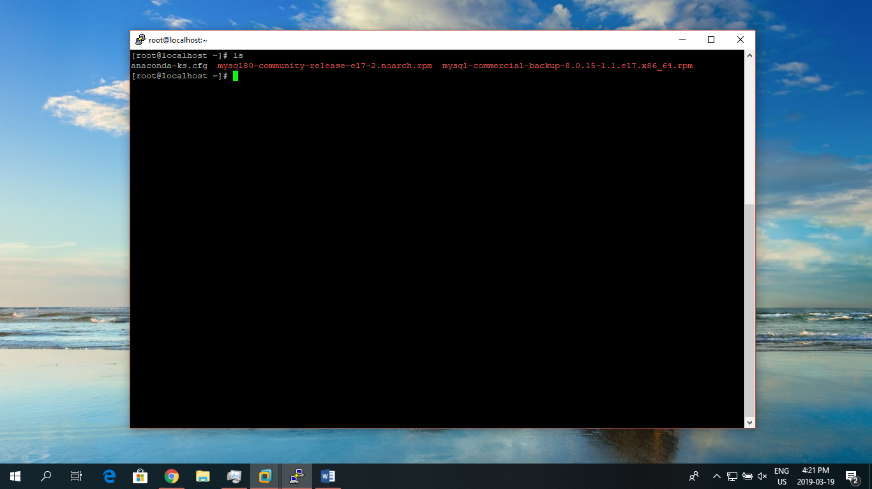
4. Install the rpm file of MySQL Enterprise Backup using: **rpm -ivh filename.rpm**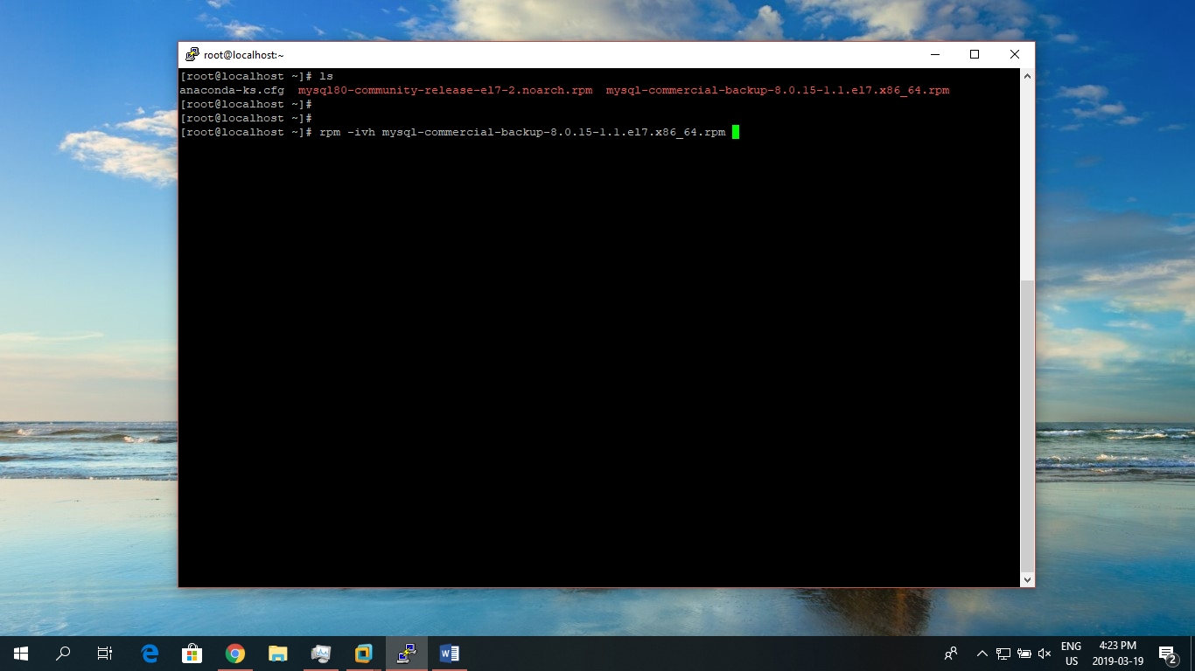
5. The **mysqlbackup** command connects to the MySQL server using the credentials supplied with the --user and --password options. The specified **user** needs certain privileges. We can either create a new user with a minimal set of privileges, or use an administrative account such as root. Enter into the MySQL prompt using: **mysql -uroot -p**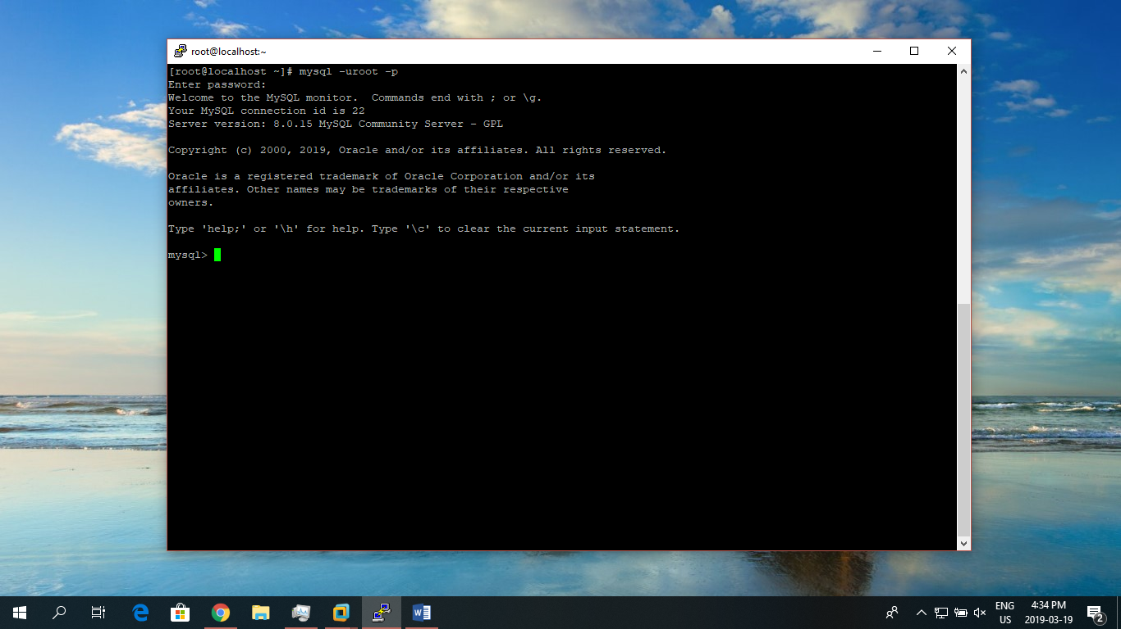
6. To create MySQL user: **CREATE USER 'mysqlbackup'@'localhost' IDENTIFIED BY 'new-password';** 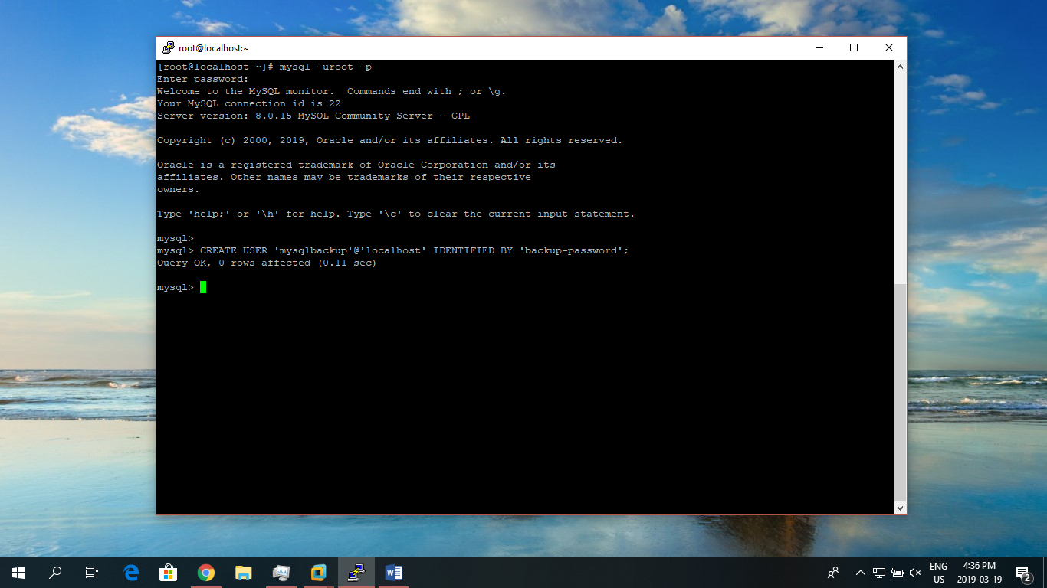
7. The minimum privileges for the MySQL user with which **mysqlbackup** connects to the server include:
   1. RELOAD on all databases and tables
   2. CREATE, INSERT, DROP, and UPDATEon the tables mysql.backup_progress and mysql.backup_history, and also SELECT and ALTER on mysql.backup_history.
   3. SUPER, to enable and disable logging, and to optimize locking in order to minimize disruption to database processing.
   4. REPLICATION CLIENT, to retrieve the binary log position, which is stored with the backup.
   5. PROCESS, to process DDL statements with the ALGORITHM = INPLACE clause.
   6. SELECT onperformance_schema.replication_group_members, to know whether the server instance is part of a Group Replication setup and, if so, to gather information on the group members (required by release 8.0.12 and later).

Use following query to grant the above mentioned permissions:

* **GRANT RELOAD ON *.* TO 'mysqlbackup'@'localhost';**
* **GRANT CREATE, INSERT, DROP, UPDATE ON mysql.backup_progress TO 'mysqlbackup'@'localhost';**
* **GRANT CREATE, INSERT, DROP, UPDATE, SELECT, ALTER ON mysql.backup_history TO 'mysqlbackup'@'localhost';**
* **GRANT REPLICATION CLIENT ON *.* TO 'mysqlbackup'@'localhost';**
* **GRANT SUPER ON *.* TO 'mysqlbackup'@'localhost';**
* **GRANT PROCESS ON *.* TO 'mysqlbackup'@'localhost';**
* **GRANT SELECT ON performance_schema.replication_group_members TO 'mysqlbackup'@'localhost';**

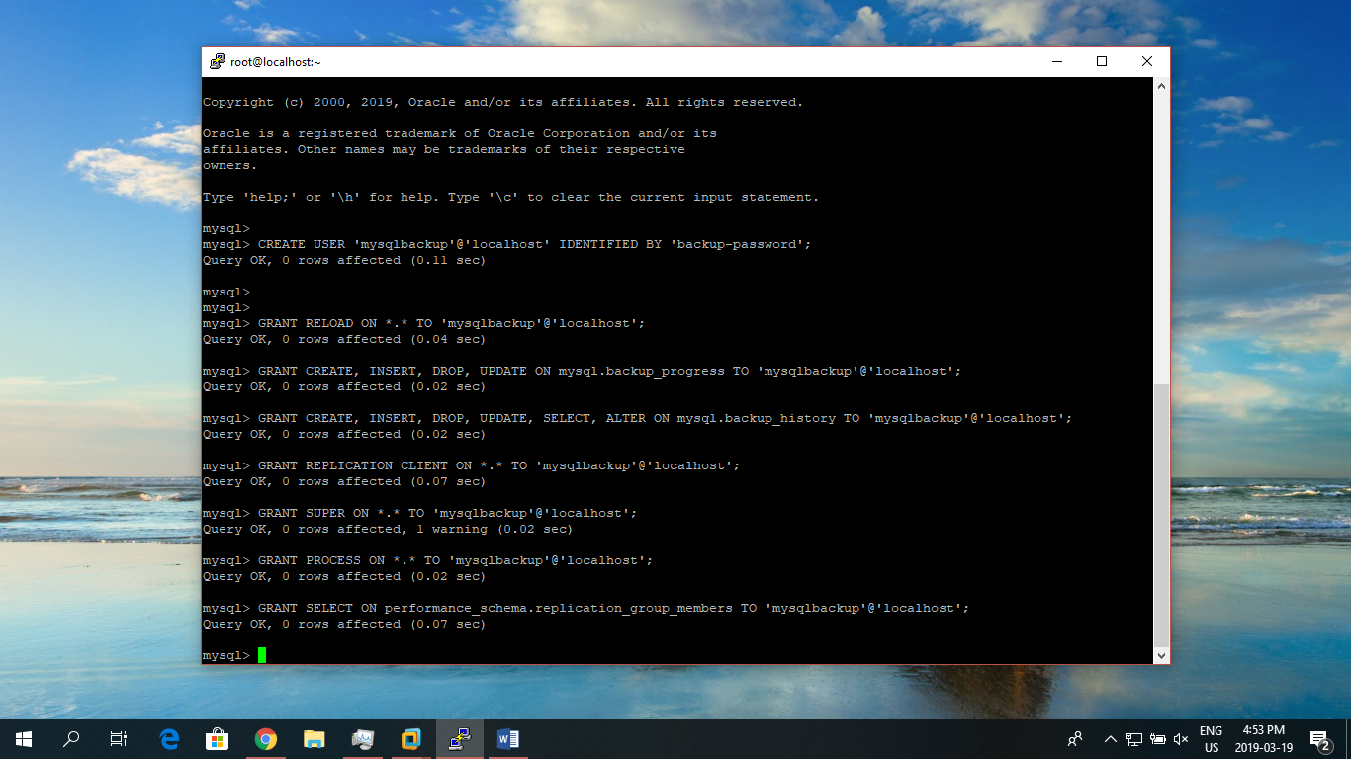

1. The following additional privileges are required when using MySQL Enterprise Backup for the first time:

* **GRANT CREATE, INSERT, DROP ON mysql.backup_history_old TO 'mysqlbackup'@'localhost';**
* **GRANT CREATE, INSERT, DROP, ALTER ON mysql.backup_history_new TO 'mysqlbackup'@'localhost';**

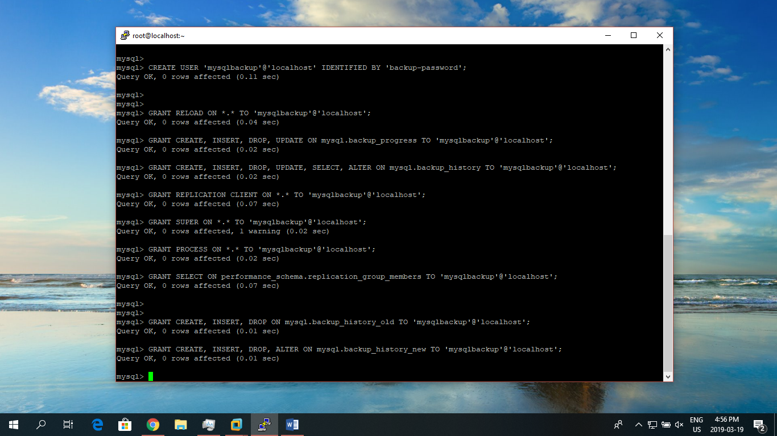

1. Create directories to store the backup file and temporary files:

**$ mkdir -p /data/backups/full**

**$ mkdir -p /data/backups/backup-temp** 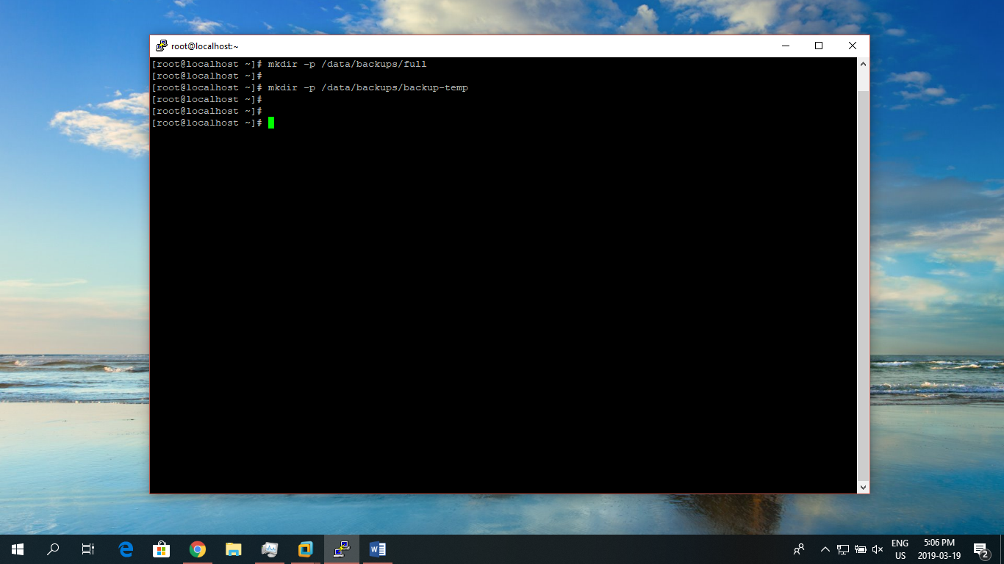

1. To backup the database use following code: 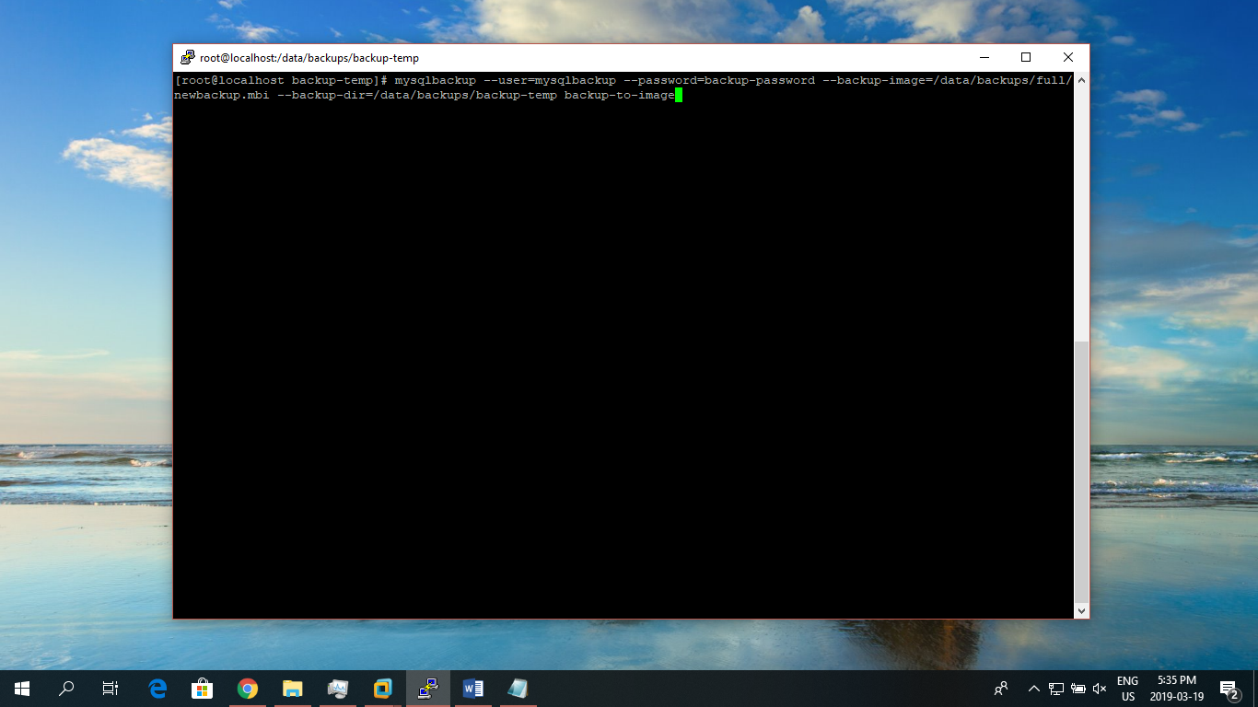
2. Check completed OK! to verify the backup process: 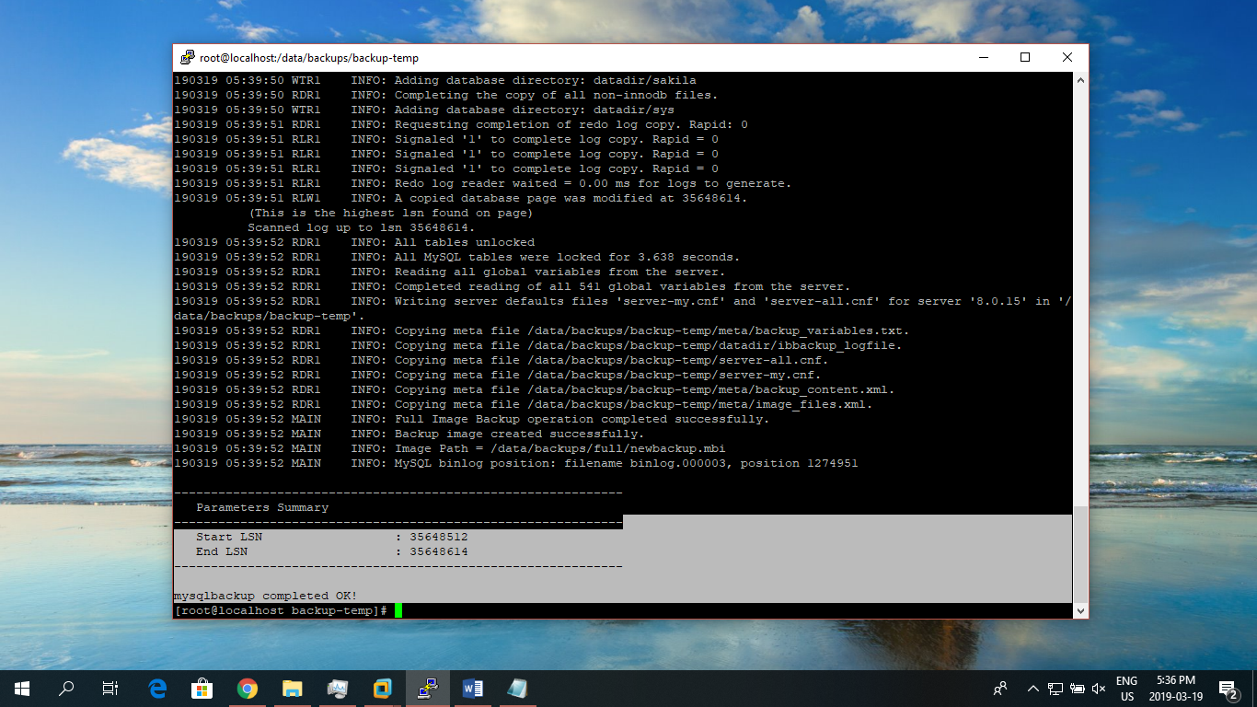
3. We can check the integrity of our backup using **validate** command: **mysqlbackup --backup-image=/data/backups/newbackup.mbi validate**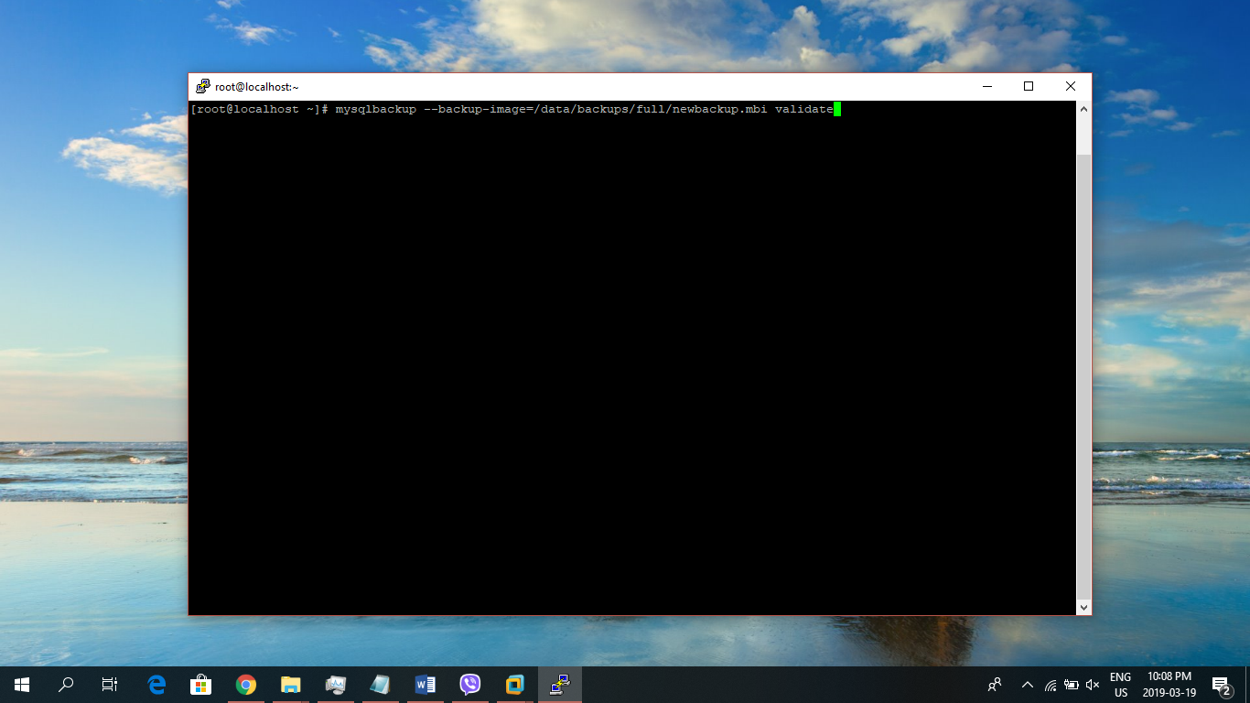
4. Check for mysqlbackup completed OK!: 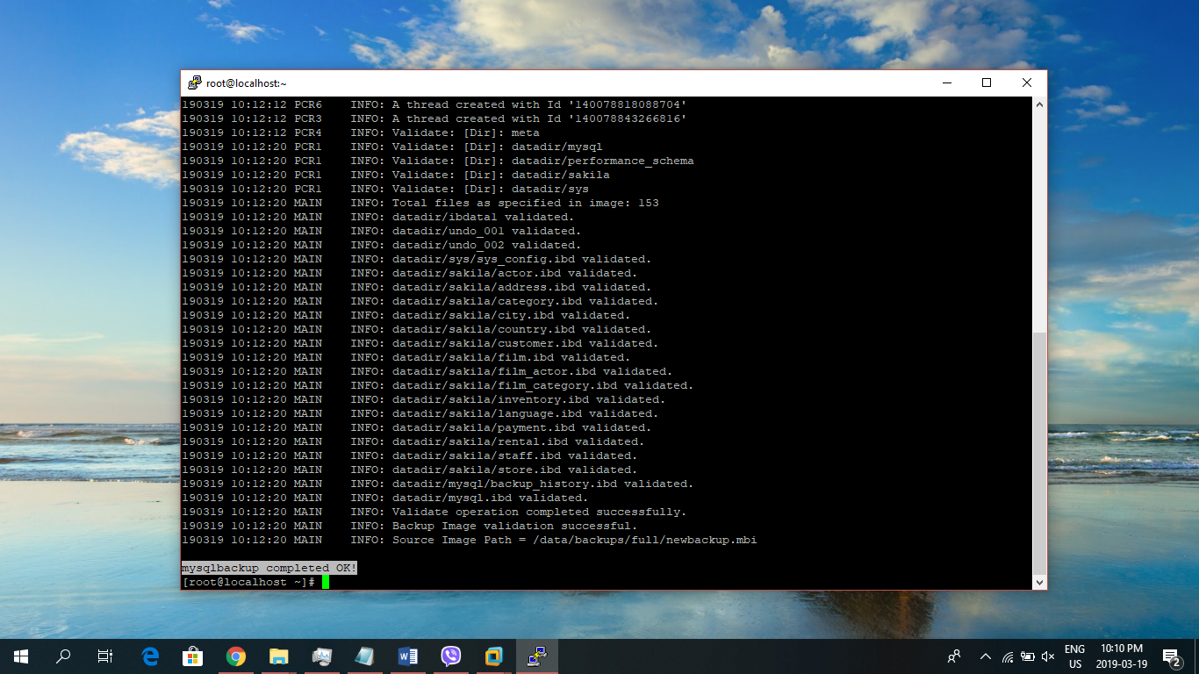

### MySQL Enterprise Restoration

STEPS:

1. Make new directory and move all the content of datadir to the created one: 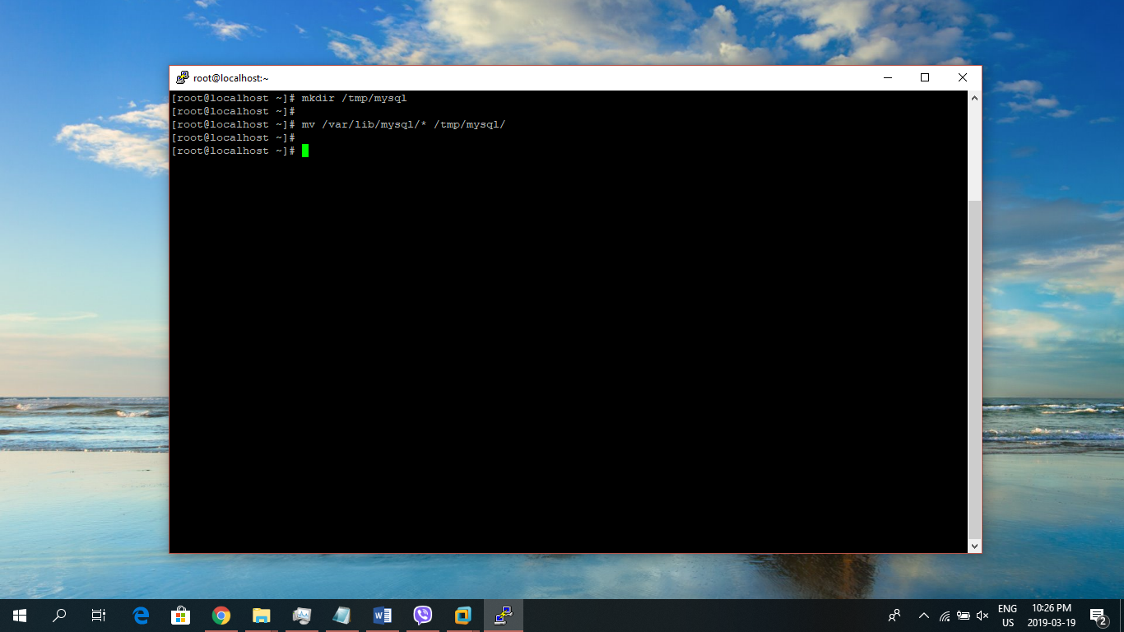
2. Shutdown the database server using: **service mysqld stop**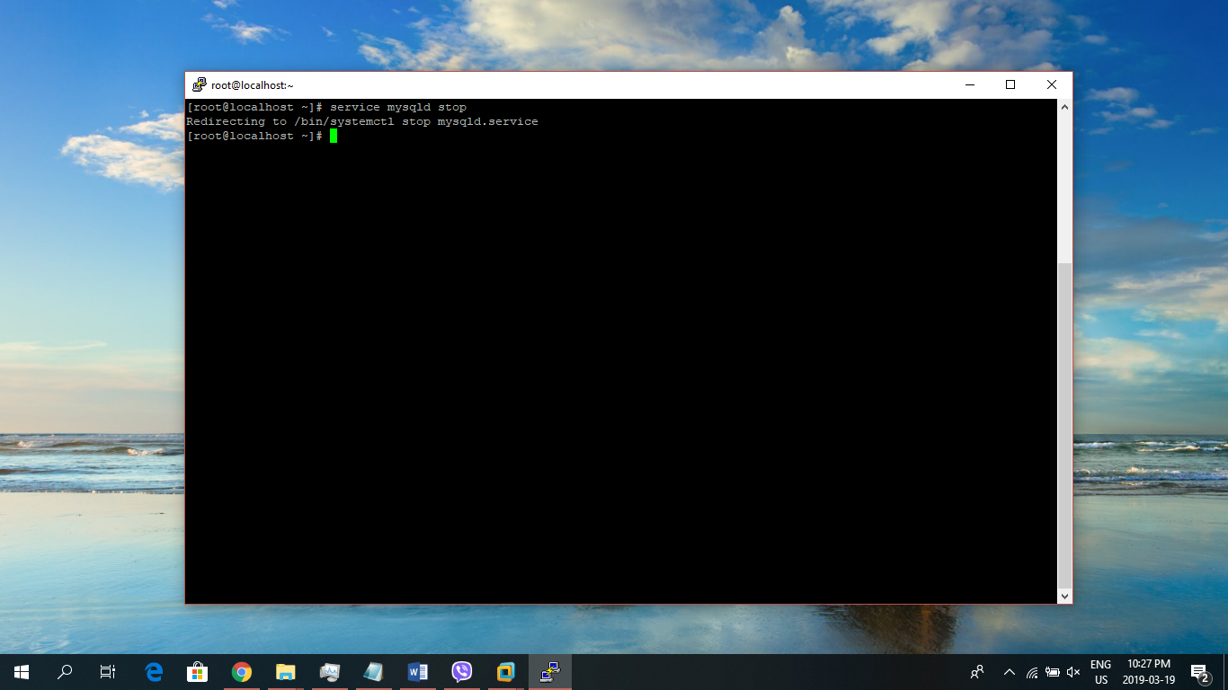
3. Use the following command to restore the backup file:

**mysqlbackup --datadir=/var/lib/mysql --backup-image=/data/backups/full/newbackup.mbi --backup-dir=/data/backups/backup-temp copy-back-and-apply-log**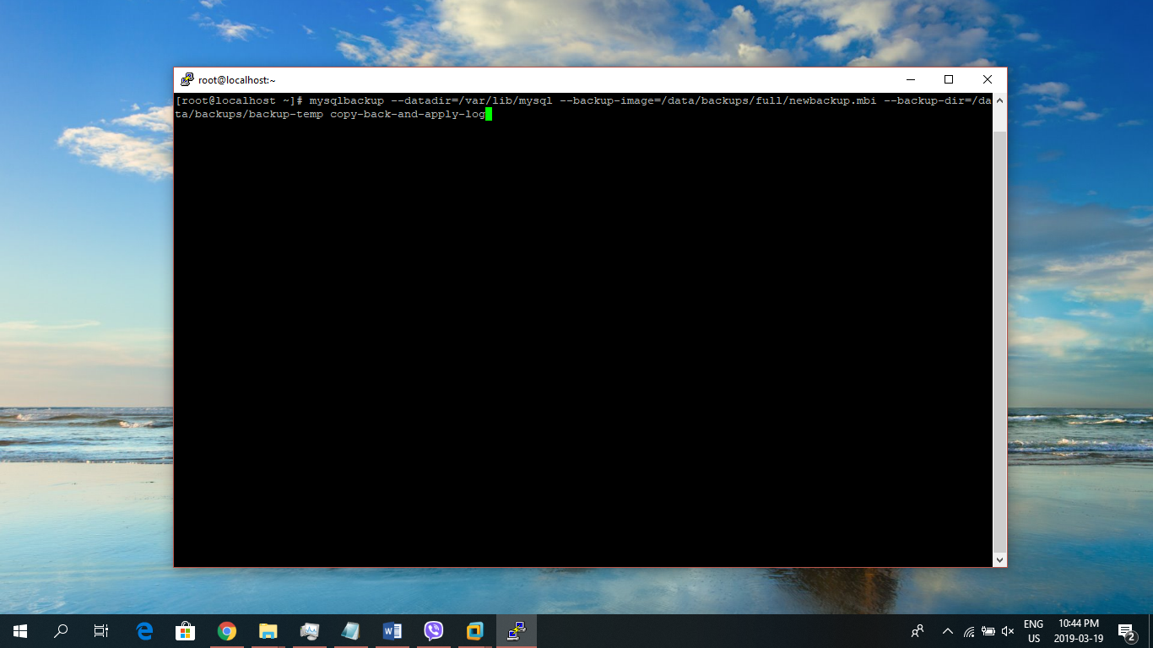

1. Now the original database directory is restored from the backup: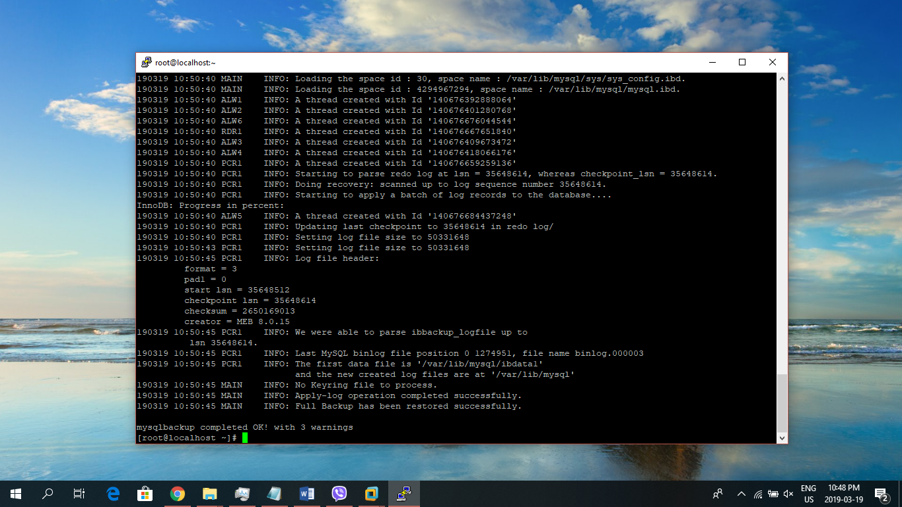
2. Changing the ownership: **chown -R mysql:mysql /var/lib/mysql**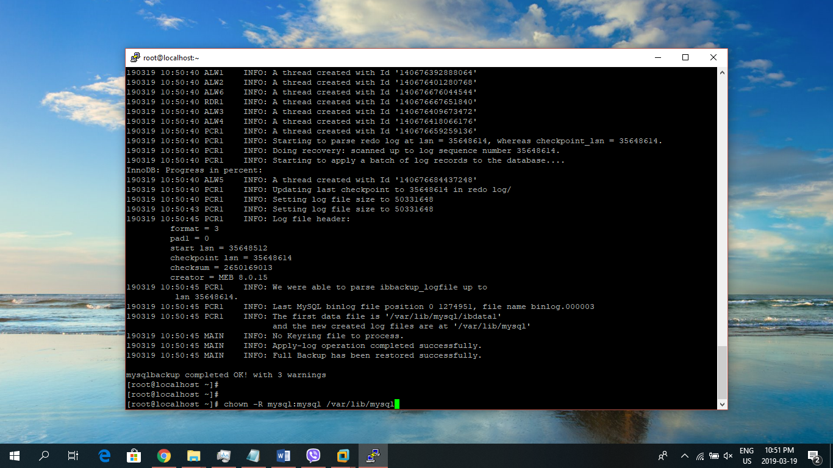
3. Start the server and check the status: 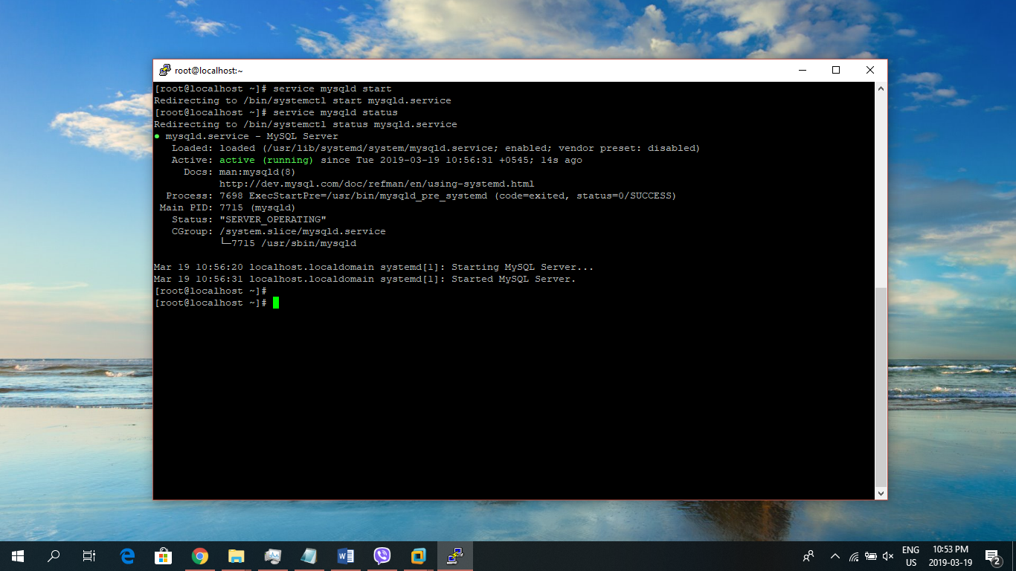

### MySQL Enterprise Incremental Backup/Restoration

STEPS:

1. Create required directories:

**mkdir /data/backups/incr**

**mkdir /data/backups/incr_temp** 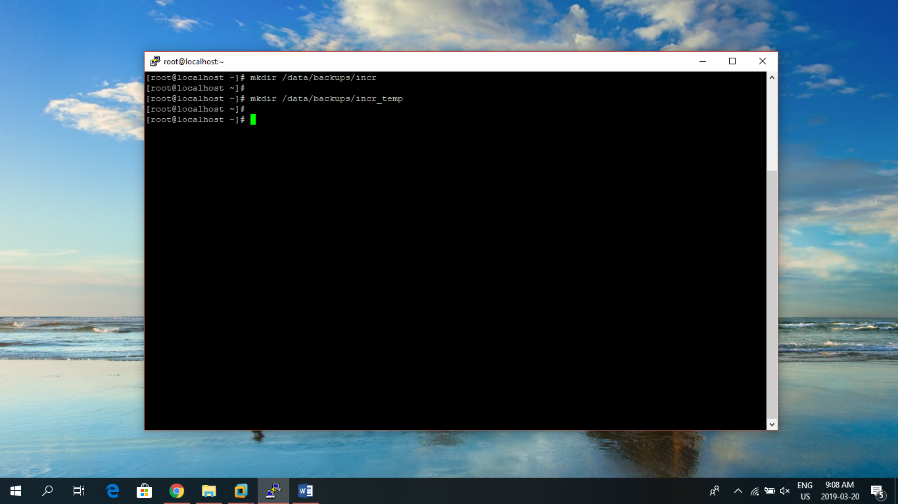

1. Incremental backup using: **mysqlbackup --defaults-file=/etc/my.cnf --user=mysqlbackup --password=backup-password --incremental --incremental-base=dir:/data/backups/backup-temp --backup-dir=/data/backups/incr_temp --backup-image=/data/backups/incr/incremental_image1.bi backup-to-image**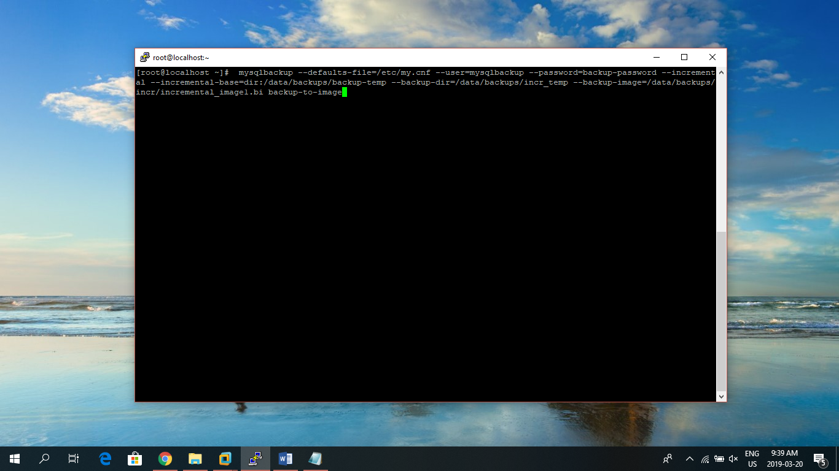
2. Check completed OK! with Start LSN and End LSN: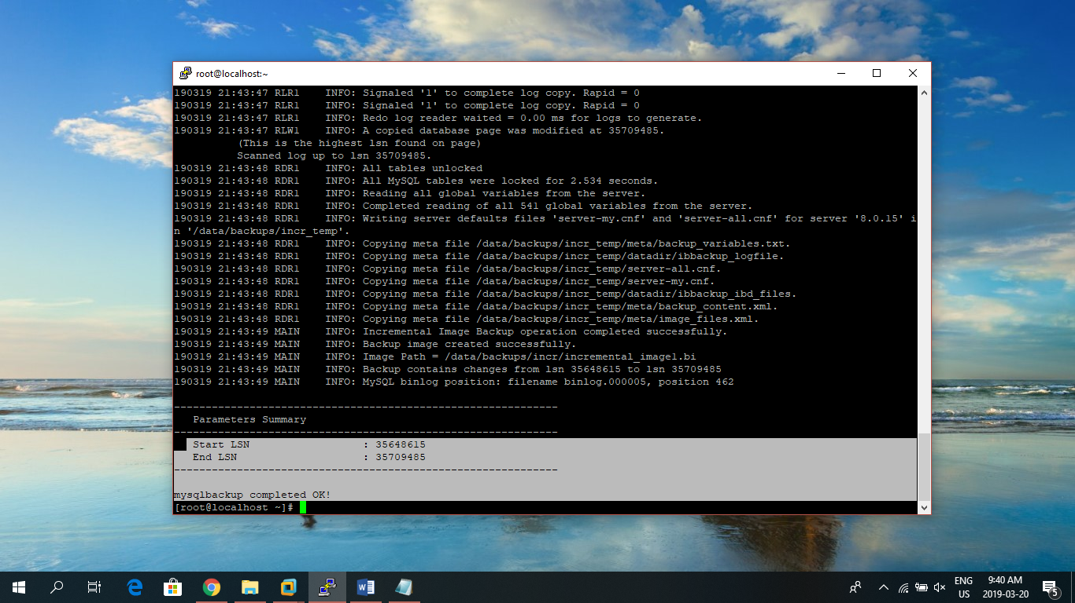
3. For restoration use the following command: **mysqlbackup –defaults-file=/etc/my.cnf –user=mysqlbackup –password=backup-password –backup-image=/data/backups/incr/incremental_image1.bi –incremental-backup-dir=/data/backups/incr_temp –datadir=/var/lib/mysql –incremental copy-back-and-apply-log**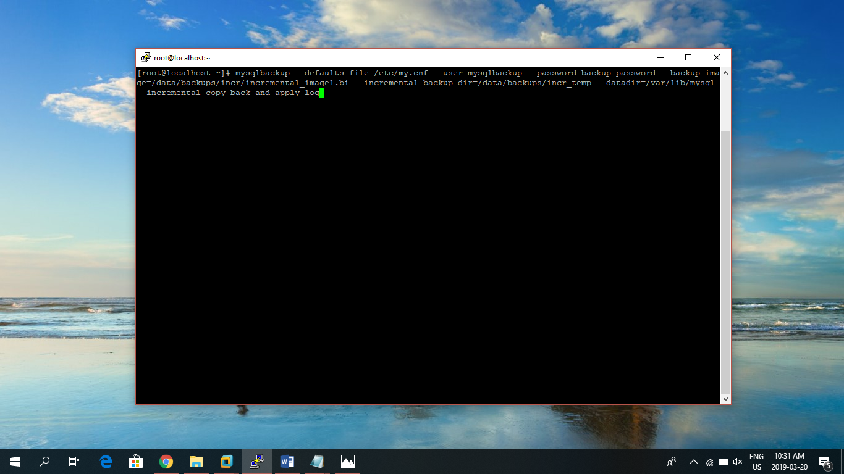
4. Incremental backup applied successfully: 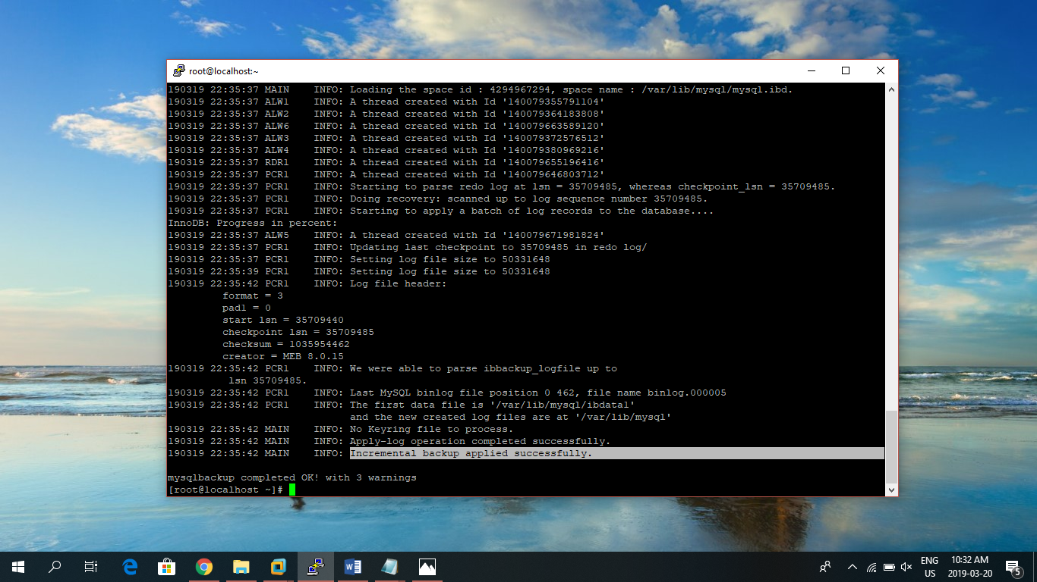

# MSSQL Backup and Restore

## MSSQL Backup

STEPS:

1. Lets us take the backup of **sample** database present in the MSSQL server: 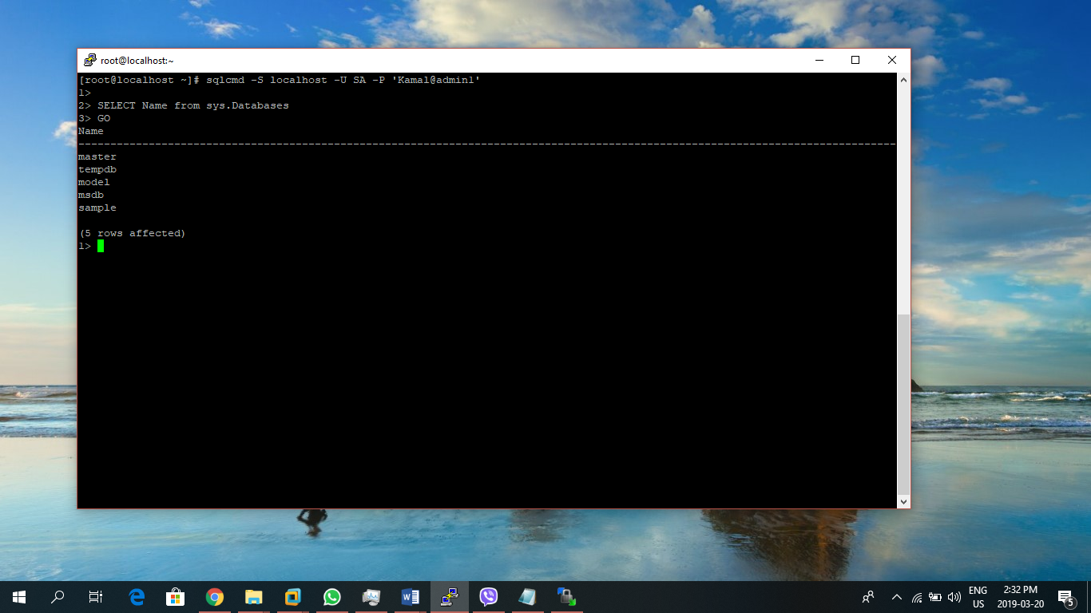
2. Use the following command to take the backup of the sample database: **sqlcmd -S localhost -U SA -Q "BACKUP DATABASE [sample] TO DISK = N'/var/opt/mssql/data/sample.bak' WITH NOFORMAT, NOINIT, NAME = 'sample-full', SKIP, NOREWIND, NOUNLOAD, STATS = 10"**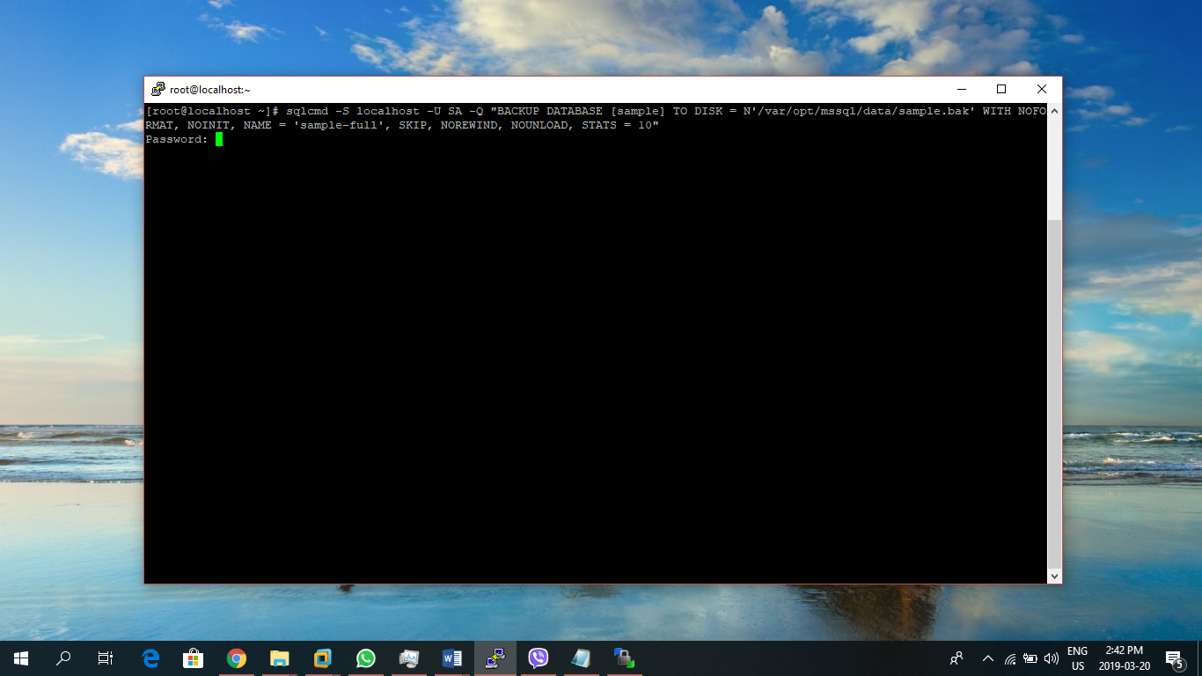
3. If successful the BACKUP DATABASE successfully message appears on the screen: 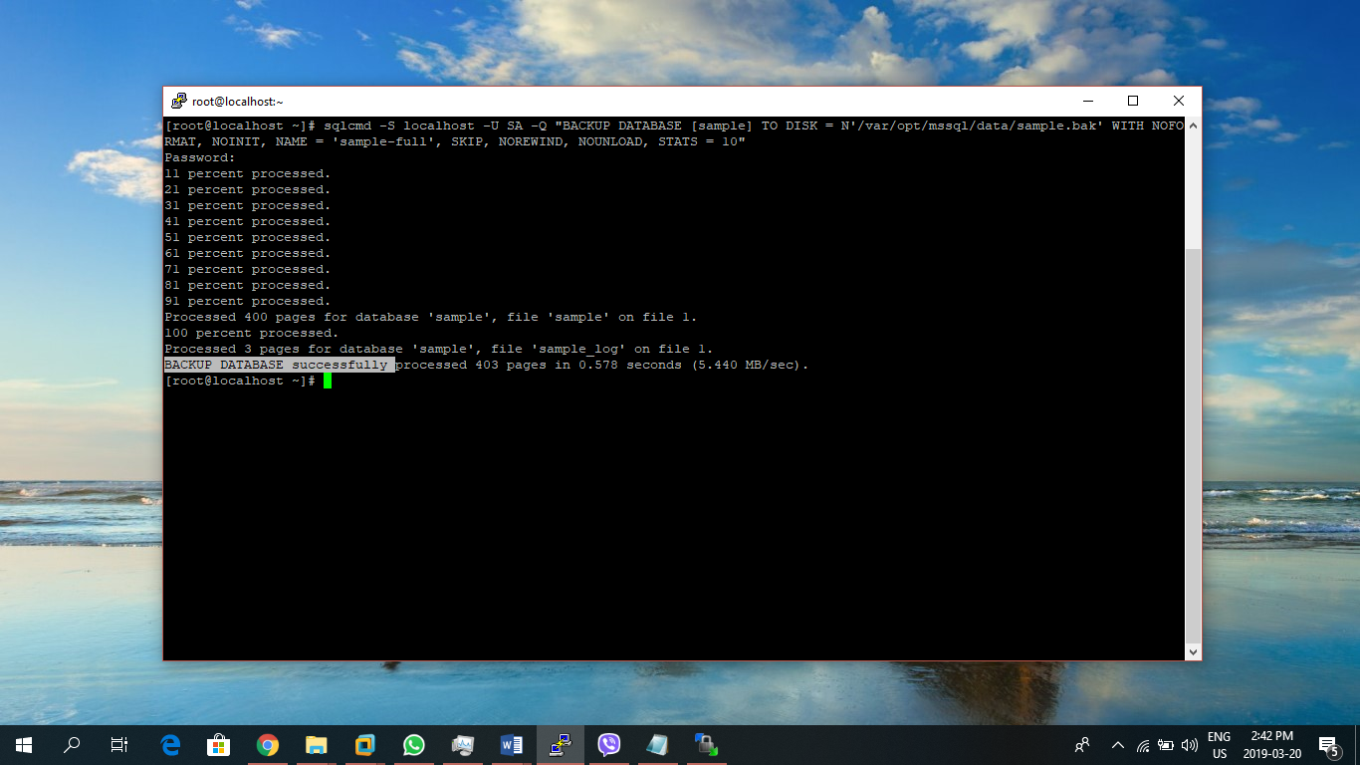
4. Now, backup Transaction Log using: **sqlcmd -S localhost -U SA -Q "BACKUP LOG [sample] TO DISK = N'/var/opt/mssql/data/sample_LogBackup.bak' WITH NOFORMAT, NOINIT, NAME = N'sample_LogBackup', NOSKIP, NOREWIND, NOUNLOAD, STATS = 5"** 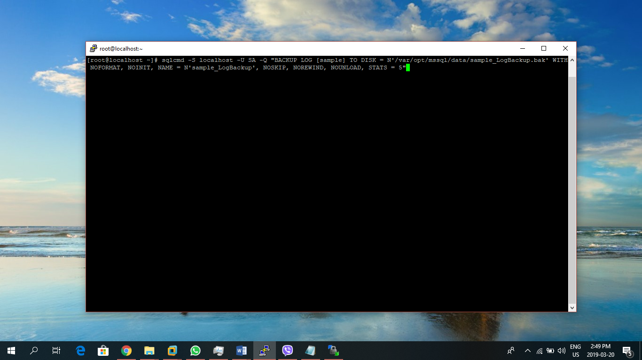
5. If successful, BACKUP LOG successfully processed will appear on the screen: 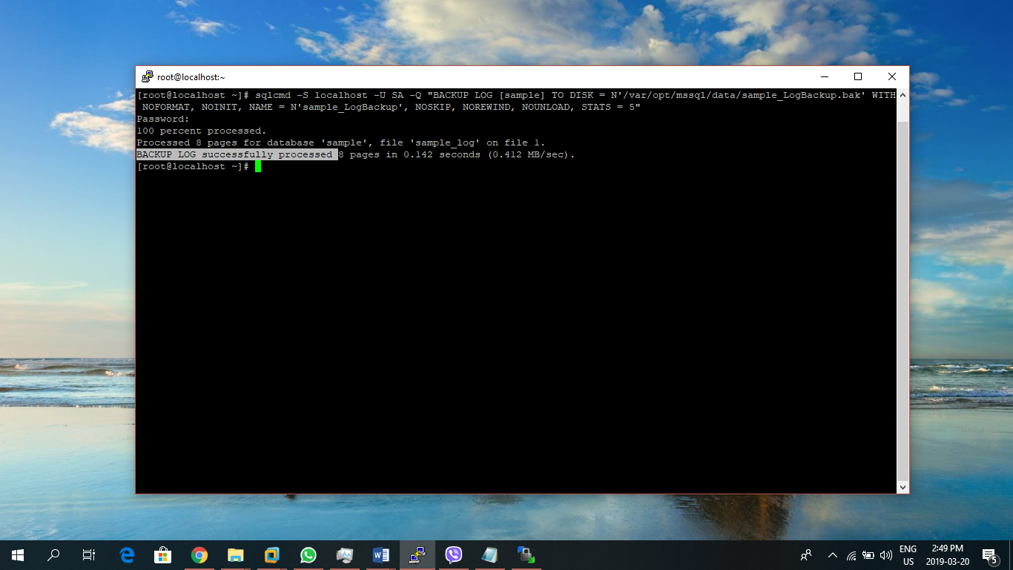

## MSSQL Restore

STEPS:

1. For restoration of the sample database backup which was previously taken can be done using: **sqlcmd -S localhost -U SA -Q "RESTORE DATABASE [sample] FROM DISK = N'/var/opt/mssql/data/sample.bak' WITH FILE = 1, NOUNLOAD, REPLACE, NORECOVERY, STATS = 5"** 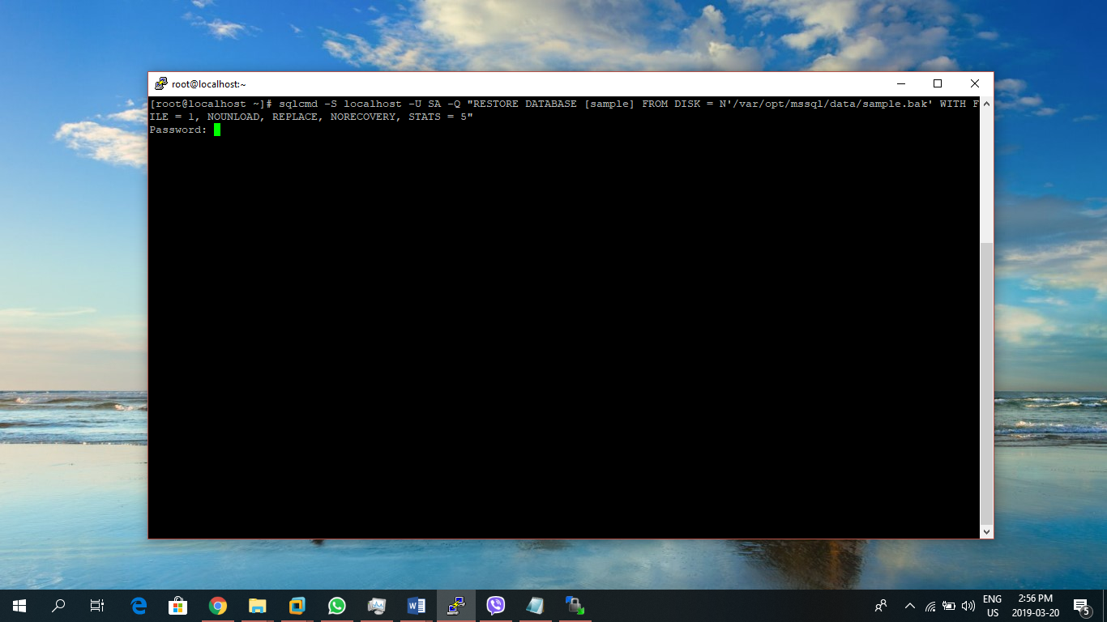
2. If successful RESTORE DATABASE successfully processed appears on the screen: 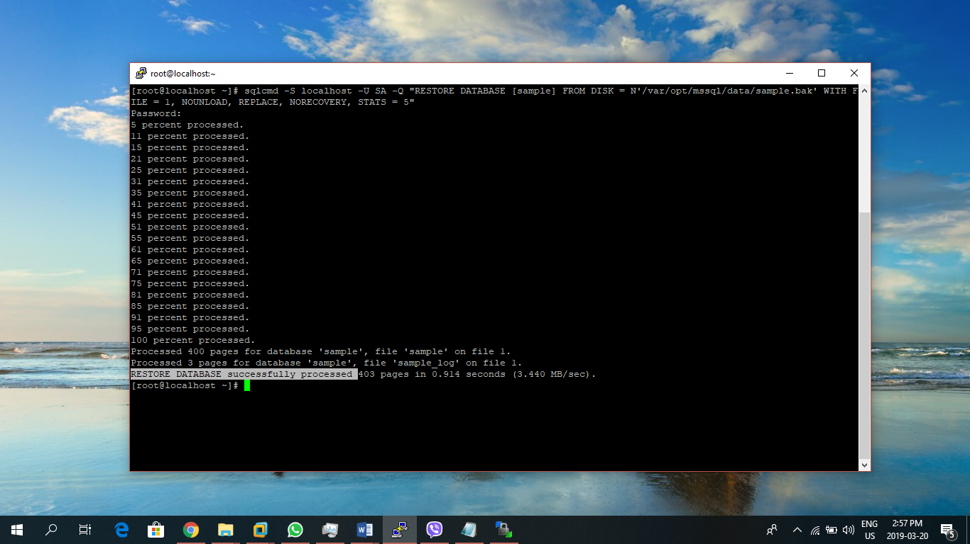
3. Restore the transaction log using: **sqlcmd -S localhost -U SA -Q "RESTORE LOG sample FROM DISK = N'/var/opt/mssql/data/sample_LogBackup.bak'"** 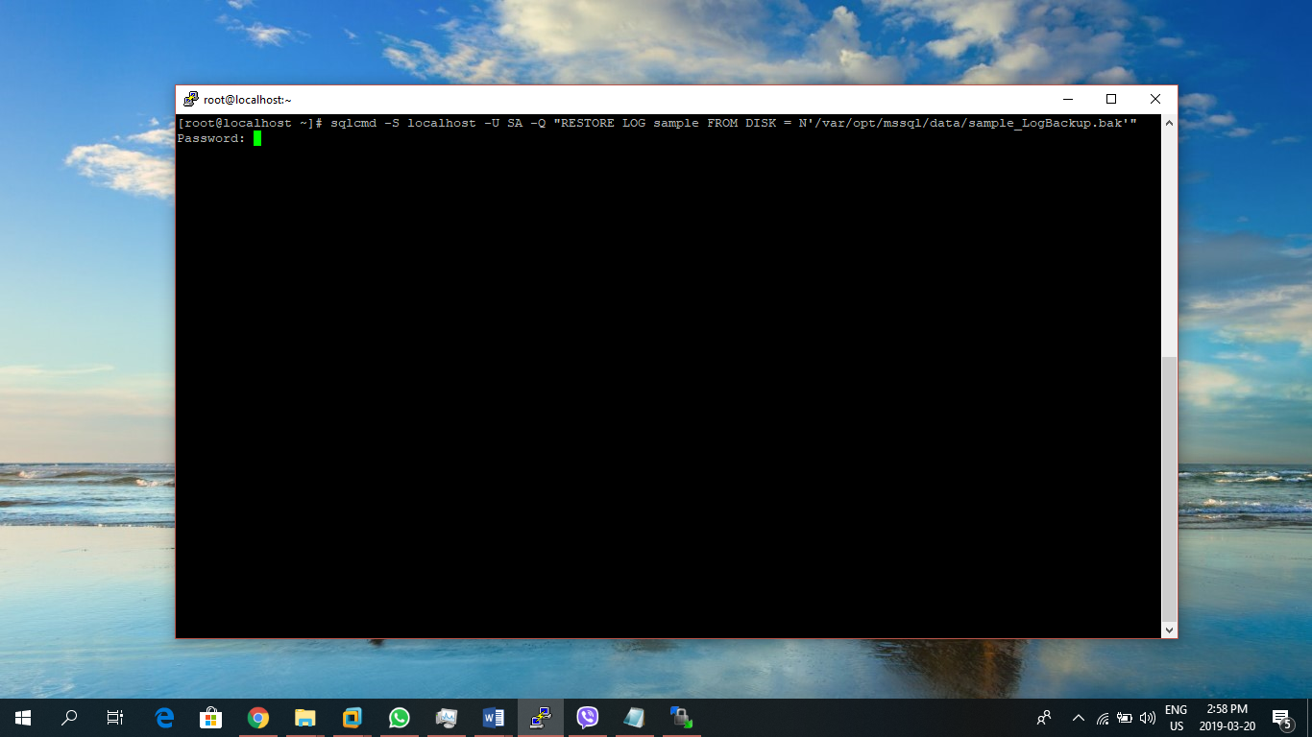
4. If successful, RESTORE LOG successfully appears on the screen: 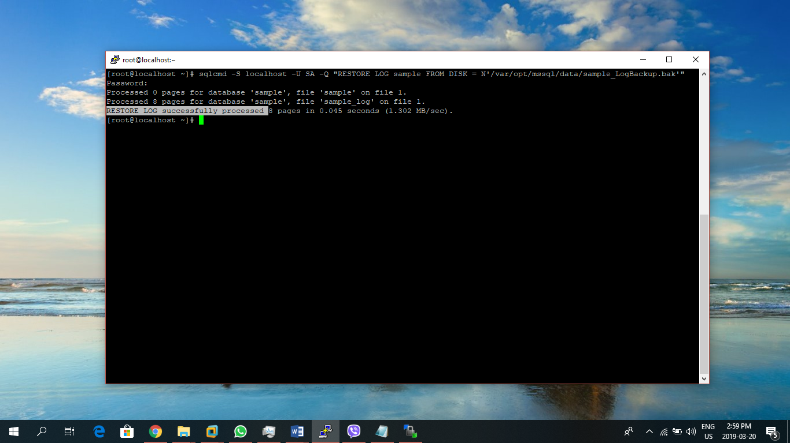

# REFERENCES

MySQL Backup using mysqldump

* <https://linuxize.com/post/how-to-back-up-and-restore-mysql-databases-with-mysqldump/>
* <http://www.mysqltutorial.org/how-to-backup-database-using-mysqldump.aspx>

MySQL Backup/Restore using Percona Hot Backup

* <https://www.digitalocean.com/community/tutorials/how-to-create-hot-backups-of-mysql-databases-with-percona-xtrabackup-on-centos-7>
* <https://bobcares.com/blog/percona-incremental-backup-how-to-set-it-up/>
* <https://www.percona.com/doc/percona-xtrabackup/2.4/backup_scenarios/incremental_backup.html>

MySQL Enterprise Backup/Restore

* <https://dev.mysql.com/doc/mysql-enterprise-backup/4.1/en/mysqlbackup.incremental.html>
* <https://dev.mysql.com/doc/mysql-enterprise-backup/4.1/en/restore.incremental.html>

MSSQL

* <https://docs.microsoft.com/en-us/sql/linux/sql-server-linux-backup-and-restore-database?view=sql-server-2017>